Preface

This Guide is intended to be read by those responsible for setting up and maintaining the templates used by the system to produce customer documents for transmission by mail, email, or fax. It assumes that you are familiar with the system and trade finance, and requires a good working knowledge of Word functionality and its underlying principles, specifically the creation of .dot files and the use of styles.

# Introduction

This chapter explains how customer documents are set up and then produced by the system during transaction processing. It lists each of the stages in the process, which are then covered in greater detail in later chapters.

It also covers the customer document template utility delivered with the system.

## Overview

The system permits your bank to design the customer documents that will be produced by the system when an event completes. It allows you to use the powerful facilities of Microsoft Word to design and set up the layout and contents of each of the documents the system will produce for transmission via mail, fax or e-mail or for internal use.

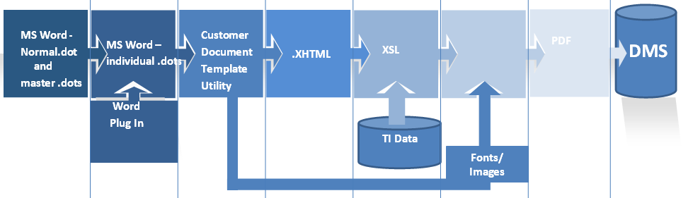

Customer documents are initially set up as Word .dot files from within the customer document template utility delivered with the system. master .dot files are used to establish common formatting elements. A Word plug-in installed with the system allows you to embed fields from the database into these .dot files. At run-time these embedded fields are populated with event-specific data (such as the customer's name and address or details of charges associated with the event) taken from the database.

Once the .dot files are completed the customer document template utility is used to convert them to .xhtml format and bundle them in to a .zip file, ready to be uploaded into the system. This utility manages the process of template file creation and maintenance using a workspace hierarchy of folders.

The utility also facilitates the creation of language variants of completed .dot files, whose text elements can then be translated into the relevant language.

The system is then used to upload the .zip file, unzip the files, and store them in the document management system (DMS).

Once they have been loaded into the DMS, the template files can be attached to the document types that will use them in the usual way (see the System Tailoring User Guide – Trade Innovation for instructions).

At run-time, whenever customer documents are generated, the system uses the document types linked to the event to determine which documents are to be produced. Where the transmission method is fax, mail, e-mail or internal, it retrieves the relevant .xhtml template file and populates any embedded fields with the relevant event-specific data. The customer document is then generated in .pdf format, and the input clerk can preview it before it is transmitted. The input clerk may be able to amend the content of text boxes (this is configurable at document type level), but will not be able to amend any other element of the generated document.

1. When a traceable document is to be produced, the system generates the main document in pdf/a file format as this file is sent to the external document tracing system for the creation of the traceable document. The main document is generated in pdf/a so that the fonts in the document will not change and so the content will still be the same as it should when the document tracing system transforms the document into a traceable one.  
     
   Copies, duplicates and internal copy of the main document are still generated in pdf.   
     
   Refer to *System Tailoring User Guide – Trade Innovation* and *Common Facilities User Guide – Trade Innovation* for more information on traceable documents.

Upon release of an event, a copy of the customer document .pdf file generated by the system is saved in the DMS.

You can forward, reprint or resend documents once an event has been released using the Master Summary window's Event History pane - See the Common Facilities User Guide – Trade Innovation for instructions.

1. The system is delivered with an integrated DMS, but your bank can implement a third party product instead. If you use the DMS delivered with the system then, provided you follow the instructions given in this Guide, the content of the DMS and the customer document utility's workspace will be kept in line. If you use a third part system, it will be your bank's responsibility to ensure that changes to template files made using the customer document utility are carried forward into the DMS.  
     
   Finastra recommends that your bank implements a version control tool to handle your .dot files.  
     
   If your bank allows the input clerk to use a third-party .pdf editor tool to amend the .pdf file generated by the system during transaction processing, then it must ensure that the amended .pdf file is saved to the DMS, as the system saves only the generated - and not the amended - version.

## The Process of Setting Up Customer Document Templates

This section lists each of the stages in creating template files and making them available for use, and identifies where in this guide you can find further information.

|  |  |  |
| --- | --- | --- |
| 1. | Install the customer document template utility. | See page 66. |
| 2. | Ensure that you have the correct .evf files in the workspace\evf folder. | See page 8. |
| 3. | Set up and deploy a Normal.dot template. | See page 11. |
| 4. | Design and create your master .dot files - one for each generic layout your bank will use for customer documents. | See page 12. |
| 5. | Design and create your individual .dot files - one for each customer document your bank will produce. | See page 15. |
| 6. | Check the templates in Word and fix any errors. | See page 28. |
| 7. | Create any language variants of the .dot templates. | See page 32. |
| 8. | Convert the .dot templates to .xhtml format. | See page 37. |
| 9. | Upload the templates to the system. | See page 41. |
| 10. | Attach the templates to the document types (and thus to the products and events) that will use them. | See page 42. |
| 11. | Test the finished documents and make any fixes that are required. | See page 43. |

## The Customer Document Templates Utility

The customer document template utility is a standalone program that handles the creation and maintenance of .dot files and their conversion to .xhtml format, and provides a mechanism for preparing files to be uploaded into the system, and for incorporating files downloaded from the system into the workspace used to create and maintain template files.

The utility is installed on those PCs on which work on the .dot files used to create templates for customer documents will be carried out.

1. If your bank uses more than one PC for this purpose, it must ensure that the content of each of the workspaces is kept in line whenever changes are made to .dot files. Finastra recommends that your bank implements a version control tool for this purpose.

For instructions on installing the utility see the Appendix.

### The Customer Document Utility Workspace

The customer document templates utility can be installed and run on any PC connected to the network. The PC must have the following software installed:

* Microsoft Windows 32bit or 64bit
* Windows Server 2003, 2008, 2008 R2, 2012
* Windows 2000, Vista, XP, 7, 8
* MS Word 2003, 2007, 2010, 2013, Office 365 (all 32-bit)
* JDK 5.0 or JRE 5.0 update 08 or higher
* PDF Adobe Reader 6.0 or higher

The templates produced by the customer document templates utility are then loaded into the system from that PC and affect every user working within that zone.

The utility requires the files it works with to be stored within a specific folder structure, referred to in this Guide as a workspace. The following illustration shows an example of a workspace.

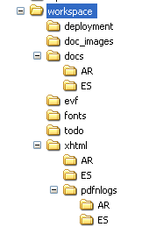

A default workspace is created as part of installing or upgrading the customer document template utility. You can create additional workspaces manually if, for example your bank uses more than one zone, with a separate set of templates for each zone; or to create a test environment prior to a major The system upgrade. When you run the customer document template utility it automatically opens the workspace you last worked in, but you can navigate to a different one.

In this structure:

|  |  |
| --- | --- |
| workspace | Is the root folder. By default the utility creates the workspace using the path:  C:\Documents and Settings\username\My Documents\workspace  Where username is your Windows user name. |
| deployment | Is where the utility stores templates.zip and fonts.zip files for upload into the system. |
| doc_images | Is where the utility stores images embedded into .dot templates as they are converted to xhtml. |
| docs | Is the folder where the Word template .dot files are held for the default language. Sub-folders contain the .dot files for language variants and are created as they are needed. Each sub-folder has as its name the unique two-character ID used in the system for that language. Sub-folders can be created manually, or from within the utility as they are needed. In the above illustration there are sub-folders for Arabic (AR) and Spanish (ES).  The system is delivered with a default set of .dot files that you can use as examples or as the basis for a documentation set.  If your bank has developed its own set of .dot files copy these into the docs folder and sub-folders.   1. Ensure that you know the two-character language codes for the languages for which your bank requires language variants. |
| evf | Is where the utility stores the .evf files that you are using.   1. Ensure that you have the correct version of the .evf files here before you begin creating .dot files (see page 8).   It also holds the language-codes.xml file (see page 32) and the mappings.xls file (see page 8). |
| fonts | Is the folder to which the utility puts font files and font configuration files. These files are referenced when previewing .pdf versions of documents to properly render the fonts. |
| todo | Is the folder to which the todo.zip file is downloaded from the system. |
| xhtml | Is the folder in which the converted template files are stored, once they have been converted to xhtml from .dot format.  As for the docs directory described above, sub-folders are created to hold language variants as they are needed. |
| pdfnlogs | Is the directory to which the utility writes log files that provide information on the success or failure of various procedures. |

The customer document templates utility is incompatible with the Word plug-in provided with the run-time system software. You will need to uninstall this application from any PC on which you intend to install the utility. See the Appendix.

### Running the Utility

You can run the customer document template utility in either of the following ways:

If, during installation, you chose to create a desktop shortcut for the utility, click on the desktop shortcut icon for the utility. It is illustrated below.

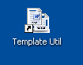

Otherwise, use the Microsoft Start button, then navigate to the file Template Util. If you accepted the default settings for installing it, it will be at:

Start|All Programs|TI Plus Utilities|Template_Utility|Template Util

To open as Administrator, the following steps can be done:

1. Run command prompt as Administrator.
2. Type cd C:\Program Files (x86)\tiplus\utilities\templateUtil to navigate to templateUtil folder.
3. From there, type TemplateUtil.bat.
4. By default, DTU log file is located in

C:\Program Files (x86)\tiplus\utilities\templateUtil\TemplateUtil.log

Whichever method you use, the main window, illustrated below, is opened.

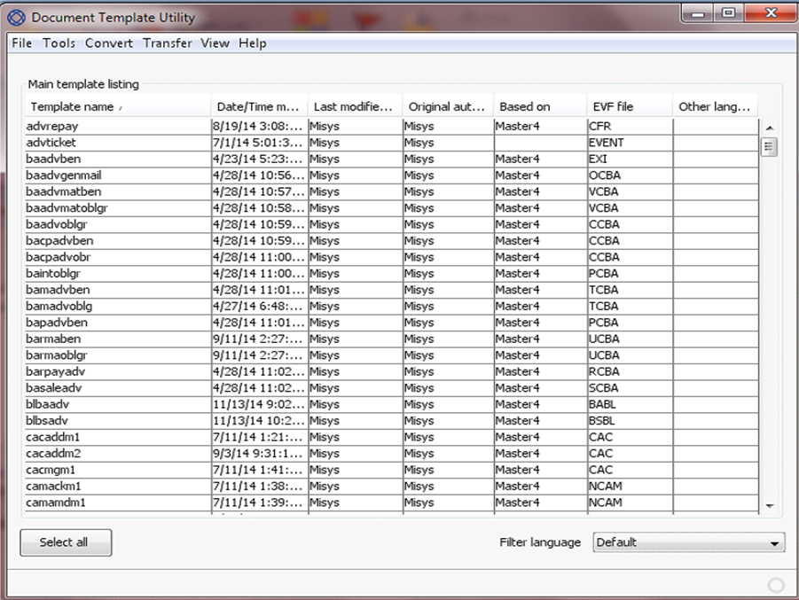

The utility automatically lists any .dot templates in the docs folder of the current workspace directory. If it encounters any that cannot be loaded, it lists them in a separate window, showing the reason why they could not be loaded.

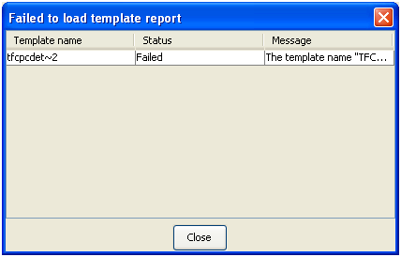

## Fonts

Generally, the following font effects are supported for conversion to .pdf for standard fonts:

* Colours
* Highlight
* Bold
* Italic
* Underline
* All caps
* Strikethrough
* Superscript
* Subscript

Generally, the following font effects are not supported:

* Small caps
* Double strikethrough
* Shadow
* Outline
* Emboss
* Engrave
* Hidden

For specific information on which fonts, and which features of individual fonts, are supported contact your local Finastra support branch.

During transaction processing, if the input clerk opens a customer document .pdf file generated by the system on a non-Microsoft operating system, the fonts on which you based your templates may not be available. In such a case the operating system’s default font will be used, with unpredictable results. To cater for such an event, and to cater for the use of non-standard fonts, the system provides a utility to allow you to embed the fonts that your documents use into the .pdf documents so that they are available when those documents are opened, regardless of the operating system used.

A font has, potentially, 4 styles:

* Normal
* Bold
* Italic
* Bold and Italic

Some fonts have a separate file for each of the four styles, while others hold all four styles within the one file.

The Arial font, for example, has the following four files:

|  |  |
| --- | --- |
| Normal | arial.ttf |
| Bold | arialbd.ttf |
| Italic | ariali.ttf |
| Bold and Italic | arialbi.ttf |

To incorporate fonts into the system select the Convert|Fonts menu option.

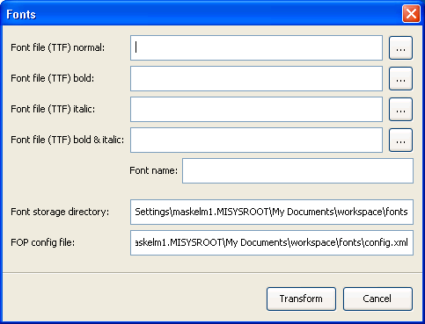

In the window that is displayed identify the first font you wish to incorporate into the system. Use the first four fields to locate each of the four files for the first font to be embedded. Windows fonts are typically found in the directory:

c:\windows\font

Once you select a font file in the first field, the utility will attempt to identify the three remaining files automatically, using the appendages 'b' or 'bd' for bold, 'i' for italic, and 'bi' for the bold and italic variations. It will display a warning if it cannot find any of these files.

Files with those suffixes that are not found will result in empty file names.

If the font has only one file, select that file in each of the four fields.

Use the Font name field to enter the name of the font.

1. This must be exactly as displayed in the template within Word. The utility uses the file name as the default value, but this is not necessarily the correct name. The file ibexconfig.xml allows you to check that you have entered the name correctly (see page 65).

Use the Font Storage Directory to identify the directory where the font metric file and configuration file are to be stored.

Do not change the value in the FOP Config File field.

Click on the Transform button to process the font. Once the font has been processed successfully, a confirmation message is displayed and you can repeat the process for the next font.

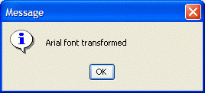

Once a font has been processed successfully, it is used the next time you convert the .dot files and upload them into the system using the templates.zip file.

If the font has already been processed, a message to that effect is displayed. The utility prompts you to confirm that you want to proceed. Press OK to process it again, or Cancel to abandon the process.

## Using the Correct .evf Files

Before you begin, ensure that the workspace in which you are working contains the correct version of the .evf files you will use.

If your bank is a new user, a zip file called starter_evf is loaded into the workspace as part of the installation process. This is the correct version of the .evf files to use for a new installation.

If your bank is an existing user, then Finastra recommends that you delete the starter_evf file and use instead a set of .evf files downloaded from the system. Log on to the system and select the relevant zone. Open the system tailoring application and select the Output|Documents menu option.

In the window that appears click on the Download evf Files link.

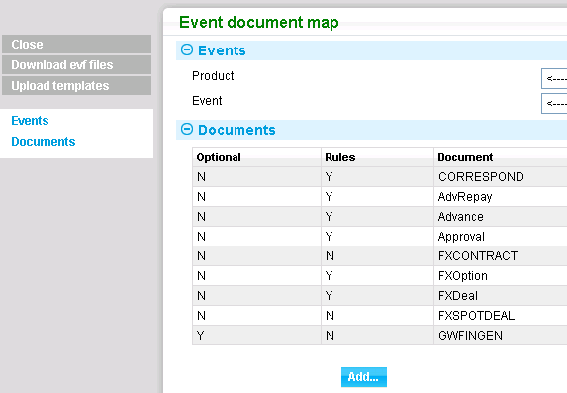

The system displays a warning message. Click on the Yes button to continue.

The system builds an .evf zip file, and displays the window illustrated below when the process is complete.

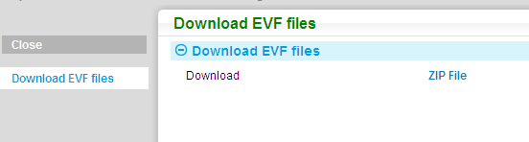

Click on the Zip File link and use the window that appears to save the file to the workspace for that zone on each of the PCs that will be used to build the customer document set. (It does not matter which folder you save the file in, although the customer document template utility looks for it in the workspace/deployment folder by default.)

Open the customer document template utility and then select the File|Workspace menu option. Browse to the correct workspace.

Select the Transfer|Import EVF Files menu option.

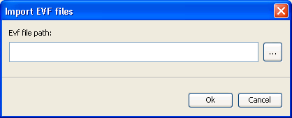

In the window that appears navigate to the evf.zip file you have just downloaded and press OK. The utility loads the .evf file set into the utility and displays a message when the process has completed. Perform this process on each of the PCs that will be used to build the customer document set.

The evf.zip file also contains a mappings.xml file which is also extracted into the workspace's evf folder as part of the import process. This file contains information on which products and events individual .evf files relate to.

# Working in Word

This chapter provides detailed information on how to use Word styles and formatting facilities to create .dot files that will produce satisfactory .pdf output.

1. This chapter identifies those features of Word that support the creation of reliable .pdf files and those that do not. You must follow the guidelines provided in this chapter to ensure that your .pdf output is error-free.

## Word Template Management

To make the most efficient use of Word's template functionality, Finastra recommends that your bank creates a hierarchy of templates.

At the top level, set up and save a version of Normal.dot that defines all the fonts and default styles that your bank will use. Provided that you set up Normal.dot in the correct location (as explained in the next section) each new .dot file you create will automatically be based on it.

At the next level, create a set of master .dot files. Each master .dot file can be used to define additional features unique to a particular customer document set, such as corporate logos and paragraph and character styles. For example, individual departments or branches might have different contact information that could be set up and maintained once in a master .dot template designed specifically for their use.

Finally, create the individual .dot templates that will be used to produce the actual customer documents. Base each such .dot file on one of the master templates. The .dot files at this level include the actual text that will appear in the customer document sent out to customers, and define the event fields to be used to extract individual information from the specific transaction for inclusion in that text.

Using this model, each of the individual characteristics of your customer documentation set is defined in one place only. If your bank decides to rebrand, or if a single aspect of your house style (such as a logo or a branch address) changes, your bank need make the change(s) in one place only, and then cascade them through your document template set.

In addition, it reduces the amount of testing that needs to be done, since a new feature can be tested once.

### Normal.dot Template Files

If your bank adopts the hierarchical model recommended by Finastra, the Normal.dot file at the top of the hierarchy must be placed in a central network directory accessible to all members of bank staff who will need to use it.

On each PC that will be used to create and maintain the templates used by the system, configure Word so that the Workgroup Template path is set up to point to the folder where your version of Normal.dot is stored. This is done using the Tools|Options menu option, then selecting the File Locations tab.

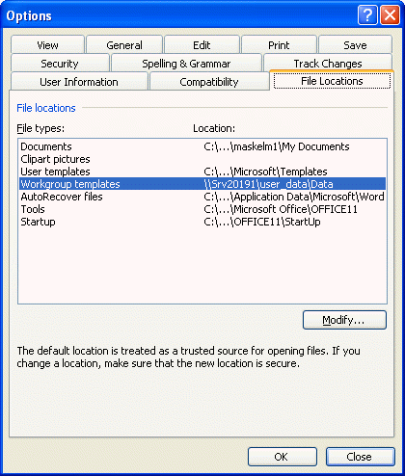

Ensure also that the User Templates path does not point to a folder where there is another Normal.dot file; otherwise Word will use this version of Normal.dot, rather than the one defined by the Workgroup Template path.

Use Normal.dot to define each of the styles your customer document set will use. This ensures that Normal.dot is a complete record of the styles your bank uses, and that only one file needs to be changed if your corporate style changes. It also means that each style is available to every .dot file your bank creates for the purposes of defining customer documents.

### Master .dot Template Files

Finastra recommends giving master .dot files a name beginning with 0 (zero), for example:

0_Master_1.dot

This differentiates them from standard .dot files and makes them easier to find when browsing for master .dots to base an individual .dot file on.

Use master .dot template files to set up the values for:

* Headers and footers and associated page margins, as described below
* Common text, including any event fields, as described later in this chapter

When you base an individual .dot file on a master .dot file, the individual .dot file automatically inherits the header and footer settings and associated page margin settings. You can also copy the text content of an existing master .dot file into the new individual .dot file too, using the Copy From button, as described in the next section).

Word permits you to set up different headers and footers for:

* First page
* Odd page
* Even page

Each header and footer can have a different depth and different content.

The following additional steps are then required to ensure that page margins and header and footer formats are generated properly in the .pdf output.

These additional steps are required because, whereas Word will automatically adjust headers and footers to match their content, .pdf requires that fixed sizes be specified.

With the master .dot file open in Word, select the File|Properties menu option, and then the Custom tab.

Create an entry for each of the header and footer layouts you have created, using the following names in the Name field:

|  |  |
| --- | --- |
| ExtentHeaderFirst | for the first header |
| ExtentHeaderOdd | for the odd header |
| ExtentHeaderEven | for the even header |
| ExtentFooterFirst | for the first footer |
| ExtentFooterOdd | for the odd footer |
| ExtentFooterEven | for the even footer |

In the Value field enter the depth of the header or footer as a numeric value followed (without a space and without a decimal point) by the unit abbreviation.

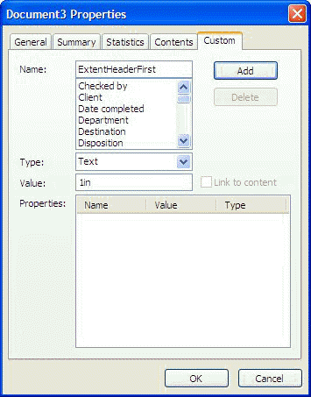

Permitted abbreviations are:

|  |  |
| --- | --- |
| in | Inches |
| cm | Centimetres |
| mm | Millimetres |
| px | Pixels |
| pt | Points |

Press the Add button to save the entry.

These values can also be set from within the customer document template utility. In the main screen, highlight the .dot template and select the Tools|Set MSWord Properties menu option.

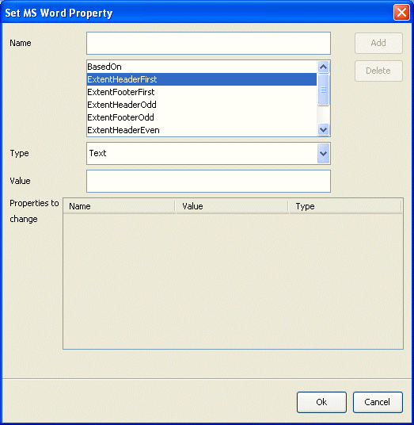

Select the first layout by clicking on it, then enter the dimension into the Value field, using the same abbreviations and syntax as in Word. The Add button is enabled. Press it to set the formatting for the selected layout.

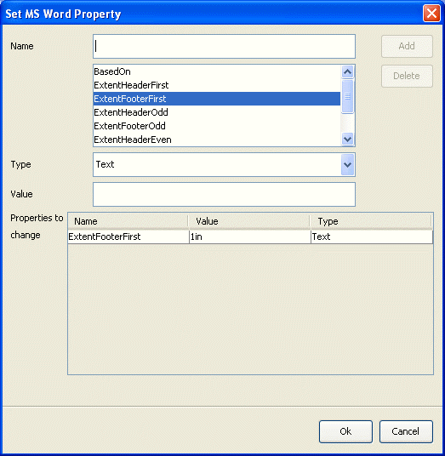

Repeat the process for each of the remaining layouts in turn. Press the OK button to save the settings.

Use this functionality for master .dot files, and also for any individual .dot files that are not based on a master .dot.

### Individual .dot Files

The individual .dot files provide the actual templates upon which the customer documents produced by the system are based. They inherit styles from Normal.dot, and take the content of their headers and footers and associated page margins from the master .dot on which they are based.

When creating an individual .dot file based on a master .dot file, you can also choose whether or not to copy the text content of the master file over into the individual .dot file. (You can, instead, copy the text content from another individual .dot file.)

1. Finastra recommends that you use the utility to create and amend individual .dot files, since it automatically accesses Normal.dot, places completed .dot files in the correct workspace\docs folder, and provides facilities for basing them on master .dot files. If you create individual .dot files outside of the utility, you must place them in the correct workspace\docs folder after you have done so.

## Creating a New .dot File

1. If your bank uses more than one zone and has different customer document templates for each zone, ensure that you are working in the correct workspace for the zone for which you want to create a new template.

Ensure also that the mappings.xml file is present in the workspace/evf folder.

Master .dot files and individual .dot files are created in the same way. In the customer document template utility select the Tools|New Template menu option.

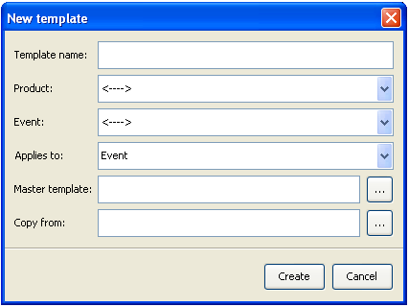

Enter the name to be given to the new template in the Template Name field. The utility does not allow you to use spaces or any of the following characters in the name:

\ / : * ? " <> | . , ~ # % ^ & = ; ) ` [ ] { }

The remaining fields are all optional.

The Product and Event fields allow you to select the product or product and event for which you are setting up the .dot template. The Applies To field allows you to specify the business area to which the document template relates. What you select in these three fields determines which event fields are available for incorporation into the .dot template. If the template is to be used by more than one product leave the Product field and Event field blank.

1. If the mappings.xml file is not present in the workspace/evf folder, instead of the Product and Event fields the utility displays an Evf File field, which you must use to identify the .evf file to be used manually.

If you are creating an individual .dot file, specify the master on which it is to be based in the Master template field. If you are creating a master.dot file leave this field blank.

The Copy From field allows you to identify an existing .dot, the content of which you want to copy into the new one.

When you have completed input press the Create button. The utility opens Word and creates a .dot file with the name provided in the docs folder. If you specified a value in the Copy From field, the content of that .dot file is displayed in your new document.

Define the .dot file in Word in the usual way.

When you close the .dot file in Word it is saved by the customer document template utility in the workspace\docs folder. The .dot file can be re-opened from the utility's main screen either by double-clicking on it, or by highlighting it, then selecting the Tools|Edit Template menu option.

## Defining the Content of the Template in Word

The following sections provide instructions on using Word facilities (at times in conjunction with add-on functionality provided with the system) to create the content of .dot template files for use in generating customer documents.

1. The instructions are intended to ensure that your .dot files result in error-free .pdf output. Consequently, they focus on those features of Word which are known to work with the customer document template utility; features not mentioned in these sections are not guaranteed to work, and so should be avoided.

Text is entered and formatted into the Word .dot file in the usual way. Finastra recommends that any formatting be applied using paragraph styles and character styles from the style sheet.

1. Since Word and .pdf output apply different approaches to line and paragraph spacing (Word defaults to no spacing, whilst .pdf applies spacing) use Word styles to define the spacing you require.

When working with .dot templates, Finastra recommends that you keep field codes displayed (this is set up in Word using the Tools|Options menu option, then checking the Field Codes field on the View tab).

Finastra also recommends that you use Word's Keep With Next feature only when necessary.

### Special Characters and Lists

The following special characters are supported:

* Bullets (but see the section on lists)
* Em-dash (long dash)
* Double quotes ("straight")
* Single quotes
* The copyright character ©
* The trademark™ character
* Ordinals
* Ellipsis…

The following Word list styles are supported:

Bullets (if your bank uses characters from a non-standard font, ensure that the font is made available to the system (see page 6)):

* Line 1
* Line 2
* Line 3

a, b, c:

a. Line1

b. Line2

c. Line 3

A, B, C:

A. Line1

B. Line2

C. Line 3

1, 2, 3:

1. Line 1

2. Line 2

3. Line 3

i, ii, iii:

i. Line 1

ii. Line 2

iii. Line 3

### Word Features Not Supported

Do not use tabs, since tabs are lost in the process of converting the template to .xhtml. Use tables or hanging indents instead to space information.

Do not use smart characters (see the Word online help for a list of smart characters) since these may cause problems when producing documents in languages other than English.

Page breaks are supported, but section breaks are not.

Use Keep With Next only when necessary.

Word's Autotext facilities are not supported.

### Embedding Event Fields

The system allows you to embed the names of fields from events and their associated master records into your Word template. During processing, when a document is produced using the template, any embedded field names are replaced with data taken from the event or master record. If an embedded field name is linked to a clause, then, during processing, the field name can be replaced with the clause (and any additional text the input clerk has added).

The fields available for embedding are determined by the product or product/event combination for which you set up the document template and the aspect of the transaction to which the document type relates. This information determines the .evf file used. There is a separate evf file for each event type in the application, and this is specified in a header field at the beginning of the template. The illustration below shows the header for an .evf called EVENT which contains fields common to all events.



The relevant .evf is selected, and the related header automatically inserted into a template, when you create it using the customer document template utility. The Insert|Insert Header menu option allows you to insert a header manually, if you are creating .dots without using the utility.

To embed a field, position the cursor where you want the field to be embedded, then select the Insert|Insert Field menu option.

In the window that is displayed use the Type field to select the type of field you want to embed. The window displays the fields of that type that are available.

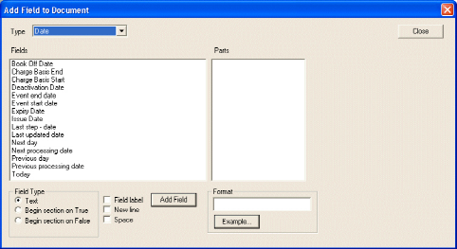

The first column lists all items of the selected type within that event. Select an item from this list and press the Add Field button. The window closes and the field is inserted in the Word template, as illustrated below.



The event field embedded consists of two markers, between which is a text string that describes the field. You can overtype this text, but do not alter the two fields surrounding it. To include the name of the field before the contents of the event field, check the Field Label field before using the Add Field button.

For some types of field, an additional level of information is available for embedding in your template. For parties, for example, you can include the actual party field in the template, and you can also include additional information, such as the party's address and customer identifier. Additional fields of this sort are listed in the second column.

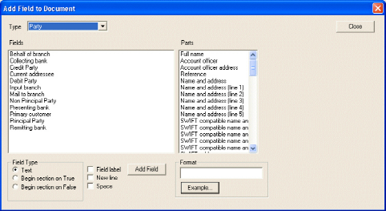

When including name and address lines, you can select the 'Name and address' entry to include all lines of the address, or you can select one or more of the numbered 'Name and address' lines separately. Additionally, structured name and address fields are available.

To include an additional field of this sort in your template, first select the appropriate item in the first column, then the field you want to embed in the second column. For example, in the window illustrated above, to include the first line of the advising bank's address in the template, select 'Advising Bank' in the first column and 'Name and Address (line 1)' in the second column.

To place the event field so that it starts on a new line, check the New Line field before using the Add Field button. Finastra recommends that you place event fields starting on a new line, since event fields can hold multiple lines of information. If you are placing an event field within a table, place it in a new cell.

To place a space before the contents of the event field, check the Space field before using the Add Field button.

The functionality used to embed fields also allows you to:

* Define the format of the field using the field in the Format pane (see page 23)
* Embed text boxes (see page 22)
* Set up conditional sections which are included in a document only if a particular field has a certain value in it (see page 26)

#### When Working with Embedded Fields

* Do not insert a paragraph breaks after the start tag, or immediately before the end tag, of an embedded field.
* Paragraph marks after the closing bracket (}) of an embedded field are removed (except when used in an editable box)

#### Database Table Fields

When you select Table in the Type field, additional fields are displayed. Select the database table you wish to insert from the drop-down list in the Table field.

The Fields section then lists all the columns in the selected database table. When you select an entry in the Fields list, the Parts section displays a further level of information for that item. To select one of these parts to be included in the template, highlight it in the Parts section, then press the  button.

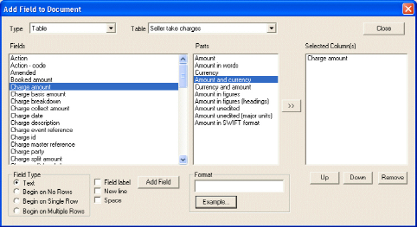

The Selected Column(s) column lists the fields from the selected database table which will be included in the template. You can select an item in this list and use the Up and Down buttons to determine the order in which the items will be displayed, or use the Remove button to remove an item from the template.

Finastra recommends that you embed database table fields into a corresponding table in the Word .dot file. Set up a table in the Word .dot file with the required number of columns, one for each part of the database table that you select. You need only set up a single row - the system will automatically create the required number of rows when a document is produced. Place the embedded database table field in the cell at which the table is to begin.

You can set up a heading row above the row to be used for data.

If the data included in a column consists of amounts (for example, charges), totals fields will be provided for you to embed in the corresponding column of the final, total, row. Use these, rather than any Word mechanism for totalling columns.

Column widths and padding vary slightly between Word and .pdf, so make columns very slightly wider than is absolutely necessary in Word. You may vary the border styles and cell formatting as required. Do not set the row height.

Database table fields do not need to be embedded in the first column of a Word table, and more than one set of database table data can be used in the same Word table.

Database table fields can be nested inside other tables.

Database table fields can be used in free text (that is, not embedded into a Word table); but problems may ensue with the resulting layout if more than one row of data is returned. Such problems can be partially mitigated by the use of optional sections (see page 26). For example, if you want to include fields from the charges database table in a template you can include three optional sections:

* The first section to be used if there are not charges to be collected. The section would result in a message to that effect being produced
* The second section to be used if there is a single charge. The section would produce details of the single charge
* The third section to be used if there are multiple charges. The section would produce details of each of the charges, in a Word table

1. Use simple text styles, and as few as possible, in tables. Heavy use of styles in tables may cause the conversion process to fail. (However, table border styles and cell formatting can be used as required.)

### Text Boxes

Text boxes are embedded fields of varying length that are not associated with event fields. They allow you to set up text that can be altered during transaction processing (provided that the template is flagged as being editable when it is linked to the document type - see the System Tailoring User Guide – Trade Innovation).

To insert a text box field into the template, position the cursor, then select the Insert|Insert Field menu option.

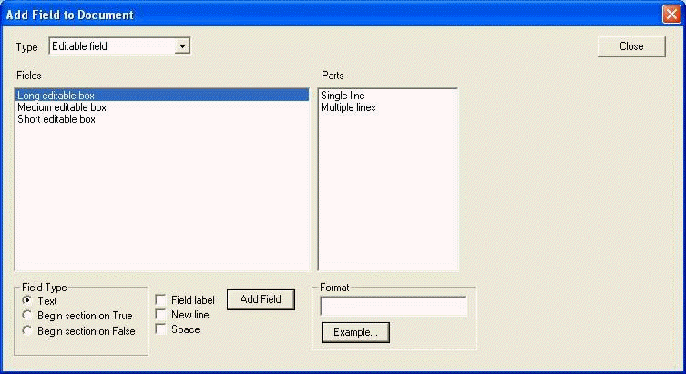

Select 'Editable Fields' in the Type field, then select whether the text box is to be long, medium or short. This setting affects the size of the text box in the generated document, but not how much text it can hold.

For multiple-line text boxes (for example, for addresses) select 'Multiple Lines' before closing the window.

The field is created in the in the Word .dot file:

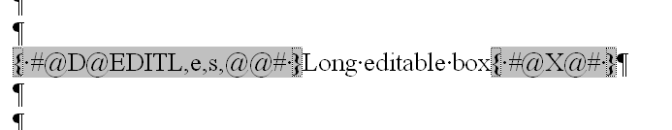

In the first field, the first letter following the EDITL code indicates whether the box is long (e), medium (m) or short (s). It is followed by the letter 'm' if the field has multiple lines. Holding text appears between the two fields, which you can overtype.

1. You do not need to enter holding text - the text boxes will work without it.

The holding text (or whatever you replace it with) appears in the text boxes when the input clerk opens the resulting customer document in the system for editing. Depending on how the template was attached to the document type, the input clerk may be able to delete or overtype the holding text (this is controlled by the Document Contains Editable Fields field - see the System Tailoring User Guide – Trade Innovation).

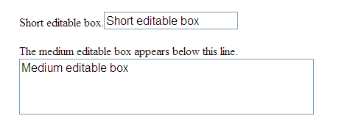

### Formatting Embedded Fields

You can format embedded fields to define how the text that is included in them will be printed. Select the field to be embedded in the usual way. Then, before pressing the Add Field button, use the field in the Format pane to define the format of the field, using syntax described in the following sub-sections.

The Example button displays an information window showing examples of the syntax you can use for particular types of fields.

1. Formatting is not currently supported for amount fields.

#### For General Text

You can convert text to all upper or lower case or combinations of upper and lower case using the \* format identifier followed by the picture format. For example:

|  |  |
| --- | --- |
| \* lower | converts everything to lower case |
| \* upper | CONVERTS EVERYTHING TO UPPER CASE |
| \* Caps | Converts The First Letter Of Each Word Into Capitals |
| \* FirstCaps | Converts the first letter of the first word in each sentence into capitals |

The following converts text from all upper case to lower case with initial capitals:

\* lower \* caps

#### For Dates

To specify the date format required on a Date field, apply the \d formatting option:

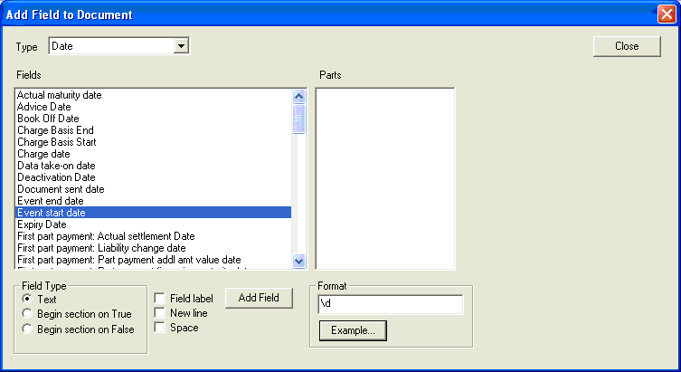

\d tells the system to apply a date format.

Then add the actual date format required:

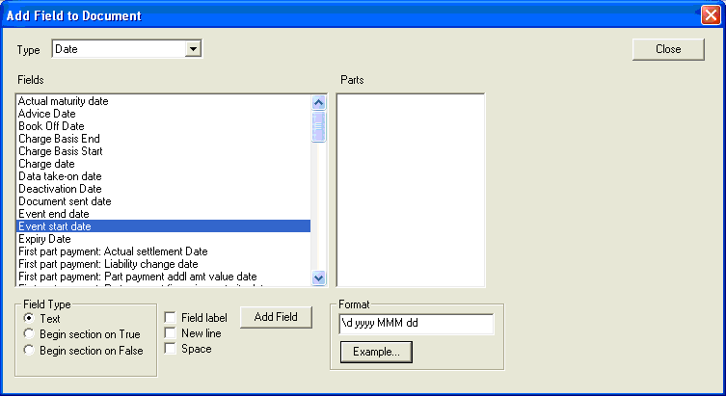

The following table explains what the various parts mean:

| Part | What it Means | Resulting Appearance |
| --- | --- | --- |
| d | Drop leading zeros from the day number | 7 |
| dd | Two-digit day number always | 07 |
| MM | Month as number | 03 |
| MMM | Three-character month | Mar |
| MMMM | Full month name | March |
| yy | Two-digit year number always | 10 |
| yyyy | Full year number | 2010 |

1. The case is important. Month must be in upper case, day and year must be in lower case.

\d is separate from the date format. That is, you can have the following specified:

|  |  |
| --- | --- |
| \d d | format as a date and drop leading zeros from the day number |
| \d dd | format as a date and always have two digits for the day number |

You can also add separators between the parts of the date, for example.

|  |
| --- |
| \d d/MM/yy  \d dd-MMM-yy  \d d MMMM yyyy |

So, for the date 23/01/2010:

|  |  |  |
| --- | --- | --- |
| dd-MM-yy | = | 23-01-10 |
| dd-MM-yyyy | = | 23-01-2010 |
| dd/MMM/yyyy | = | 23/Jan/2010 |
| dd MMMM yyyy | = | 23 January 2010 |
| EEEE, dd MMMM yyyy | = | Saturday, 23 January 2010 |

Ordinals are handled using the '#o' notation in the following way:

|  |  |  |
| --- | --- | --- |
| dd'#o'-MMM-yy | = | 23rd-Jan-10 |
| dd'#o'-MMM-yyyy |  | 23rd-Jan-2010 |

and so on.

For superscript ordinals the '#O' notation is used:

|  |  |  |
| --- | --- | --- |
| dd'#O'-MMM-yy | = | 23rd-Jan-10 |
| dd'#O'-MMM-yyyy |  | 23rd-Jan-2010 |

and so on.

### Conditional Sections

You can insert conditional sections, allowing the same template to be used for several situations. Conditional sections are initiated by embedding an event field in the usual way. Whether the conditional section is then included in the customer document depends on whether the event field at the start of it has a value in it or not.

To create a conditional section position the cursor at the point where the section is to start, then select the event field to be embedded in the usual way. Before pressing the Add Field button to add the field:

If the conditional section includes a table or an item from a table, select:

|  |  |
| --- | --- |
| Begin on No Rows | If the section is to be displayed when there are no items in the table. |
| Begin on Single Row | If the section is to be displayed when there is one item in the table. |
| Begin on Multiple Rows | If the section is to be displayed when there is more than one item in the table. |

Otherwise, select:

|  |  |
| --- | --- |
| Begin Section on True | If the section is to be included only when the field has a value in it. |
| Begin Section on False | If the section is to be included only when the field is blank or, for amounts, zero. |

The system inserts markers to show the start and end of the conditional section.

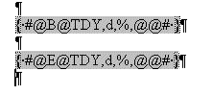

Type the content of the conditional section - including any fixed text and embedded fields and tables - as required within the conditional section markers.

1. It is important that these begin and end markers appear in a similar formatting context, so that, if the content between the markers is deleted, the result still makes sense. The begin and end markers should be:

* In free text
* Or enclose a table
* Or both occur within the same table cell
* Or both occur within the same table column, enclosing any number of rows

You can nest conditional sections. The name of the conditional section is attached to both the start and end markers. This enables you to nest conditional sections, each identified by a different field name, as in the following schematic example:

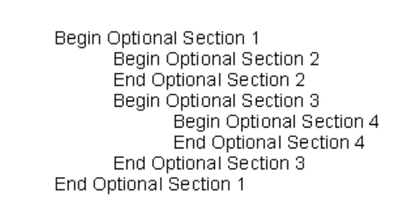

### Graphics

You can embed images into a .dot template using standard Word functionality. The following types of graphic files are supported:

* .jpg
* .png
* .gif

Word drawing objects are not supported.

Graphics can be incorporated into Word .dot templates either by dragging and dropping them or by using the Word Insert|Picture|From File menu option. Browse to the file to be used, then highlight it and press the Insert button.

1. Finastra recommends that you try to keep image file sizes to a maximum of 0.5MB.

Although images can be resized within the template, it is better to have them the correct size before embedding them.

To resize an image, right click on it and select Format Picture|Size and change the height and/or width as required. Ensure that Lock Aspect Ratio and Relative to Original Picture Size are checked.

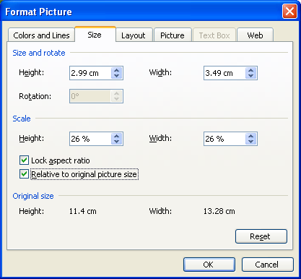

Images can be positioned in tables (but may need to be resized), in conditional sections (for example, to display different images depending on whether the addressee is a gateway customer or not) and headers and footers.

Images can be placed in conditional sections used in conjunction with headers in order to produce different output depending on whether the recipient is an external client or an internal one (such as another branch).

As .dot files are converted to .xhtml format the customer document template utility stores each individual image in the doc_images directory. If an image is used in more than one .dot file, the utility recognises this and stores a single copy of the image file.

### Routing Information for Fields for Fax Documents

When producing fax, mail and e-mail documents the system allows your bank to set up generic information required by the printing, faxing or e-mail service that is to be used. This generic information is implemented using the system’s standard clause mechanism.

This data (metadata) is then generated and passed to the relevant service with the associated document details themselves when the document is produced.

This generic data is set up using four special reserved clauses, one for each of the different transfer methods:

|  |  |
| --- | --- |
| #FAX | For faxes. This contains fields required by your fax system and will typically contain the addressee fax number, but might also contain fields specific to the fax service. |
| #MAIL | For mail. This might contain additional context information for your printer service. For example a cost code might be included for internal bank purposes. |
|  | 1. This standard clause is used to pass printer and printer attributes to the standard printing service. You must set the clause as shown below if your bank is using the standard printing service:   PRINTER:<<tPRTN,s,%>>  <<tPRTA,*,FULL,s,%,L>> |
| #EMAIL | For e-mail. This might contain special details for the e-mail system. |
| #EMAILAO | For e-mail. This might contain special details for the e-mail system for the Account Officer. |

The following illustration shows an example of a standard clause for #FAX that includes the addressee's fax number.

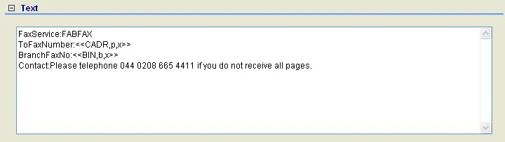

The metadata is resolved when the document is produced and passed to the service on release.

The system is delivered with three generic templates - emailcvr, mailcvr and faxcvr - for use in the production of cover letters for transmission via email, fax and mail respectively. These can be used as the basis for additional cover letter templates.

## Checking and Previewing a Customer Document

Facilities are provided to help you check a .dot template from within Word. You can also preview it in Word, but what you see will provide only an approximation of what the finished document will look like.

### Checking the Templates

1. When you have finished setting up a .dot file, you must validate it in the way described in this section, and fix any errors that are reported. If you do not, the errors will be reflected in the customer document .pdf file produced during transaction processing.

The Insert|Check Fields menu option checks on the validity of event fields and blocks of conditional text. It checks that:

* The starts and ends of conditional code blocks match
* The event fields exist and have the specified type

It also detects most formatting errors for currently supported event field syntax, and identifies some obsolete forms.

A scan of the template is performed and any errors detected are displayed at the end of the scan.

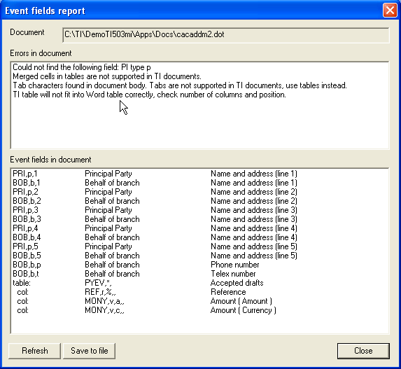

The window lists:

* Any errors found in the document (including validation to check the document's suitability for conversion to .pdf)
* All the event fields included in the document

When you select an item in either of these lists it is highlighted in the Word document, so that you can see exactly where the error that needs correcting is, if relevant.

Once you have corrected an error press the Refresh button in the window illustrated above to re-check the template.

The Save to File button saves the contents of the validation report to a text file.

### Previewing the Templates

When working in Word, the various views available provide an idea of how your finished document will look.

However, Word makes fine adjustments to spacing on a document, which can be influenced by many factors, including, for example, the printer currently selected; .pdf production will make different adjustments, so pixel-level reproduction of the Word layout seen during template creation cannot be expected.

In addition, if you use embedded fields, those fields act as place-holders for data that will vary in size; and conditional sections will always be present.

Therefore, the Preview view in Word will not give an accurate representation of how the finished document will look; it will, instead, provide only an idea of the general layout of the finished document.

Finastra recommends therefore that you set up a test the system environment for the purpose of testing customer documentation production, so that you can check the final .pdf output before going live with your customer documentation set.

## Working with Legacy .dot Files

If you are an existing Trade Innovation customer upgrading to the system, you will have already defined a set of .dot file. These will need to be revised to ensure that they can still be used to produce customer documents for the system.

For each .dot file remove the existing formatting in the following way:

* Open the file via the customer document template utility
* Select the Format|Styles and Formatting menu option to display the Styles and Formatting panel
* Click on Control-A to select all the content of the file
* Select the Styles and Formatting|Clear Formatting menu option in the Styles and Formatting panel

This removes all formatting, including any invisible formatting that might confuse the conversion process.

Set up Normal.dot and master .dots, as described earlier.

Then work through each .dot template, replacing those elements that are not supported by the conversion process. Rework the template, following the guidelines provided in the rest of this chapter, then validate it and correct any errors.

## Summary of Do's and Don'ts when Working in Word

#### Do

* Use Normal.dot files and master .dot files to control fonts, styles and formatting.
* Use the customer document utility when setting up .dot files for customer documents.
* Use styles to apply formatting to text rather than ad hoc attributes.
* Implement a version control system to help you keep track of your .dot files.
* Develop a convention for naming master .dot files, so that they can be easily distinguished from individual .dot files in lists and browsers.
* Ensure each language is set up in the system before starting to create .dot templates for it using the customer document template utility.
* Make any specialist fonts your bank uses available to Word and to the system before beginning work on your .dot set.
* Ensure that you are using the correct .evf file at all times.
* Use only those smart characters that are supported for .pdf production.
* Make the spacing in tables slightly wider than needed, to allow for the differences in Word output and .pdf output in this respect.
* Ensure that conditional sections have the same style applied to their start and end markers.
* Use simple styles, and as few as possible, in tables.
* Since Word and .pdf output apply different approaches to line and paragraph spacing (Word defaults to no spacing, whilst .pdf applies spacing) use Word styles to define the spacing you require.
* Use simple text styles, and as few as possible, in tables. Heavy use of styles in tables may cause the conversion process to fail. (However, table border styles and cell formatting can be used as required.)
* Validate each .dot after completing its layout and formatting.
* Use only the supported image types - .jpg, .png and .gif.

#### Don't

* Do not use tabs.
* Do not use section breaks.
* Do not insert paragraph markers into embedded fields (except text boxes).
* Do not use Word drawing objects or diagrams.
* Do not use Word's Autotext facilities.

# Creating Language Variants of the Templates

This chapter explains how to set up different language versions of the templates used to generate customer documents.

It also outlines the translation facilities provided by the system.

## Overview

The system allows you to set up different language versions of the templates used to generate customer documents. Whenever a template is used during transaction processing to create a customer document, the system will automatically create the document in the language of the recipient, provided a template in that language has been set up (your system's default language is used otherwise).

The system also provides translation facilities. The trade finance dictionary (see the Static Data Maintenance User Guide – Trade Innovation) allows you to identify the different languages in which your bank will produce customer documents and to provide translations in those languages of the standard text strings used by the system. In addition, the system provides a method of translating text strings taken from the database and incorporated into embedded fields from the default language into the language of the document addressee.

The workspace\docs folder and the workspace\html folder each contain a sub-folder for each of the different language versions your bank will use. Each such sub-folder has as its name the unique two-character ID used in the system for that language. Sub-folders can be created manually, or from within the utility as they are needed.

1. Language variants are supported only for those languages that have been defined in the language-codes.xml file.

## Setting Up the Customer Document Template Utility for Template Creation

The Customer Document Template Utility must be setup before templates can be created. In the Customer Document Template Utility, select Transfer | Import EV Files.

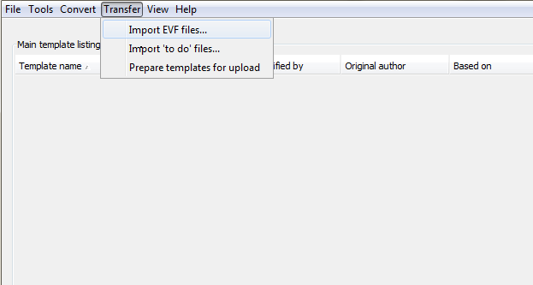

Browse to the deployment folder of the workspace where languages-codes_no_evf.zip is located. Select the file and click Open. Click Ok.

## Producing Language Variants

1. The drop-down list in the New Language window is populated with values provided by the language-codes.xml file, which is located in the workspace\evf folder. This file includes a list of language codes, and their related descriptions. You will need to edit this file so that it includes entries for each of the languages your system supports. The language codes entered in it must have a corresponding entry in the database, as set up using the static data maintenance application.

To set up different language versions of one or more templates, in the customer document template utility highlight the template(s) for which you want to create a new language version, then select the Tools|New Language menu option.

In the window that appears select the language and press the OK button.

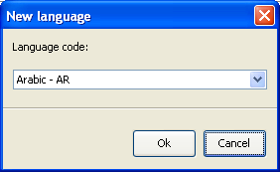

The utility creates copies of the .dot templates and places them in the folder:

docs\XX

where XX is the two-character language code. If this folder does not exist the utility creates it.

If you selected a single template, the new .dot version of that template is opened for you to translate. If you created language versions of more than one template, the utility's main view changes to list templates in that language.

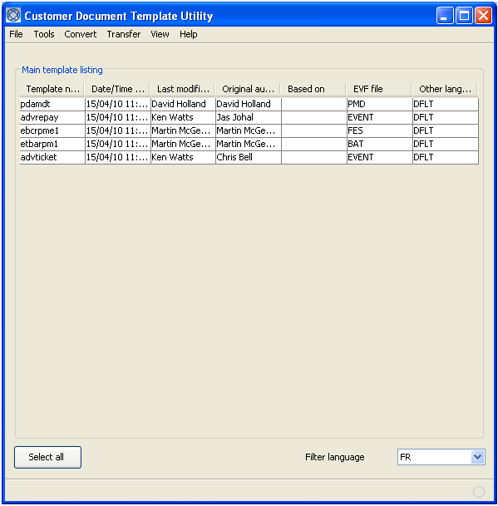

You can open them in the usual way for editing.

When you select the View|Main menu option, the customer document template utility lists templates that exist in the default language. For each such template, the Other Languages column shows the two-character code of each of the languages for which you have created a language version of that template.

You can use the Filter Language field to select a language and list templates created for that language. The Other Languages column then shows DFLT (for the default language) as well as the two-character language codes.

The language-version .dot files are processed in the same way as default-language .dot files. That is, once created, they are converted to .xhtml format, then loaded into the system using the templates.zip file.

### Translation Facilities

Once you have created a language variant of a .dot template file you can overtype the text in that template so that it is in the relevant language. The system has additional facilities to aid the production of templates in languages other than the default. These include:

* Translation files, which allow you to provide translations of text strings taken from the database and incorporated into embedded fields at run-time
* The ability to translate the descriptions of certain static data items
* The ability to translate text strings stored in the trade finance dictionary and used in constructing customer documents

#### Translation Files

The .dot templates used to generate customer documents can be configured to include event fields. When a customer document is generated, the information from the event field is taken from the database and included in the final document as text. When information taken from the database is embedded into customer documents in this way, some information may appear in the default language. The system provides a method of translating such text strings from the default language into the language of the document addressee. This is done using translation files.

The translation file facility uses translations specified in text files called XX.trs (where XX is the two-character language code given to that language in the system). There is one such file for each language that is supported for document production and they are held in the same directory structure as the document templates for the corresponding language.

The translation file consists of a series of lines, each of which defines a single text substitution. Each line has the following format:

Original|Translation

where Original is the word or phrase to be translated and Translation is the word or phrase to replace the Original.

For example:

Insurance Certificate|Certificat d'Assurance

To open a translation file for editing, in the customer document template utility's main screen set the Filter language field to the language of the translation file you wish to edit, then select the Tools|Edit Translation File menu option.

The first time you use this menu option a standard Windows prompt appears, asking you to select the program to be used to open the file. It can be opened and edited using a text editor such as Notepad. (Subsequently, the system should remember which program to use.)

If the file already exists, it is opened using the program you selected. If it does not exist, it is created.

The values you enter into the .trs file are case sensitive, and there are no spaces either side of the separator character.

#### Static Data Items

For some static data items you are able to translate their description into the other languages supported by your system.

When you enter a description against such a static data item it is stored as the default language version of that description, and also as the version to be used for all the other languages supported by your system, unless you provide translations.

If you provide a translation of a description for a particular language then the description's translation is used instead of the default description when customer documents are generated in that language. If a customer document is generated for a customer with a preferred language for which no translation has been provided, then the default language version of the description is used.

Static data item descriptions are translated into another language using the static data maintenance application's Countries|Static Language Variants menu option. See the Static Data Maintenance User Guide – Trade Innovation for instructions.

#### Trade Finance Dictionary Text Strings

The system is delivered with a trade finance dictionary, which includes text strings used when constructing the documents delivered with the system. Each entry in the dictionary consists of a unique code and the text string itself. The system creates a default dictionary, with English text, as part of the installation process.

Use the static data maintenance application's Country|Languages menu option to add the language into which you wish to translate the trade finance dictionary. The action of creating a new language creates a new set of dictionary entries for that language with English text, which you can then translate.

Then overwrite the text strings in the different language versions of the dictionary with the translations.

See the Static Data Maintenance User Guide – Trade Innovation for instructions.

# Incorporating the Templates into the System

This chapter explains how to use the customer document utility to convert the .dot files into .xhtml format, and then upload them into the system and link them to the document types that will use them.

## Overview

Once you have completed your .dot templates ensure that they, and any master .dot files, are in the correct workspace\docs folder. The process for incorporating them into the system then has the following stages:

Convert the .dot files into .xhtml format. (see page 37)

Prepare the. xhtml files for uploading into the system (see page 39).

Upload the templates into the system (see page 41).

Link each template to the relevant document type(s) (see page 42).

The following sections describe each of these steps in turn.

## Converting the .dot Files into .xhtml Format

To convert the .dot files to .xhtml format, highlight the files to be converted in the utility display and select the Convert|Templates|Current Languages menu option. (This menu option converts the version of the .dot file that is in the language currently selected in the Filter Language field. To convert all language version of a .dot template select the Convert|Templates|All Languages menu option.)

A progress window is shown.

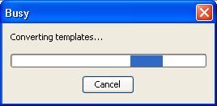

1. If a user selects all or a large number of templates in the DTU and tries to convert them, it may display an error of “PasteAndFormat command not available”. The workaround is to select a smaller number of templates for conversion. It does no harm if any template is converted again during this batching of the work.  
     
   The DTU uses JaCOB to call the MS Word APIs (PasteAndFormat is one of the commands) for converting the document templates to XHTML. PasteAndFormat uses system clipboard. The templates are processed in a loop and it would sometimes get an error about the PasteAndFormat command not being available.  
     
   So running the conversion function should be treated like a server function and needs to be left to get on with the batch work. Also, the user should avoid using their computer instance of MS Office (Outlook, Excel etc.) during the script running to help avoid this problem.

When the conversion is completed the utility displays a window that lists each .dot file and shows whether it was converted successfully or not.

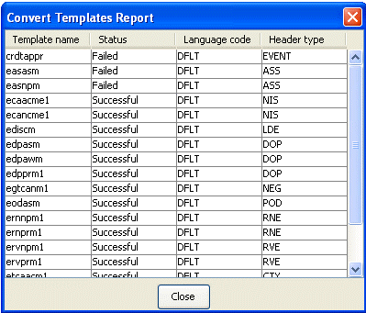

Double-clicking on an entry opens the log file produced by the conversion process. This is produced in:

* workspace\xhtml\pdfnlogs

for the default language, and in:

workspace\xhtml\pdfnlogs\XX

where XX is the language code, for language variants.

For each .dot file successfully converted a corresponding .xhtml version of the document is created in:

workspace\xhtml

for the default language, and in:

workspace\xhtml\XX

where XX is the language code, for language variants.

Once a template has been successfully converted, you can preview its layout by:

1. Run the pdftester JAR file.
2. Set up the workplace by clicking File|Open.

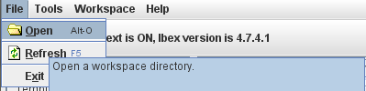

1. On the window that appears, click the workspace used in your customer document template utility then click Open.

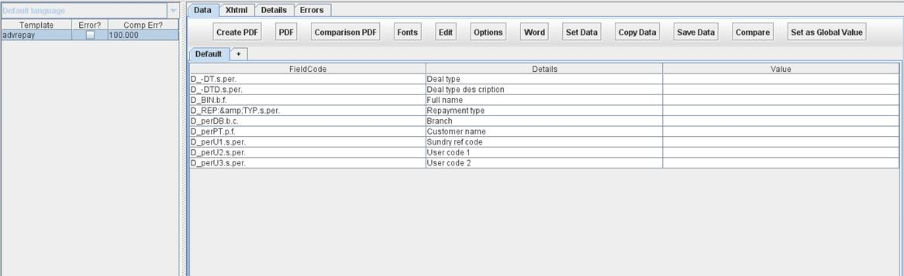

The converted templates will appear on the left pane.

You can also preview the PDF format by selecting Create PDF| PDF.

1. As in Word, the preview here provides only a general idea of the layout and appearance of the customer document.

## Preparing the .xhtml Files for Upload to the System

The .xhtml files are uploaded into the system in the form of a zip file called templates.zip. The templates.zip file is created in the deployment directory using the customer document template utility's Transfer|Prepare Templates for Upload menu option. The utility includes in the templates.zip file each .xhtml file found in the workspace\xhtml folder, and in any language-version sub-folders, excepting those created from master .dot templates.

Apart from .xhtml files, the templates.zip file may also contain translation files and image files.

When the utility has created the templates.zip file it displays a report listing the files included in it.

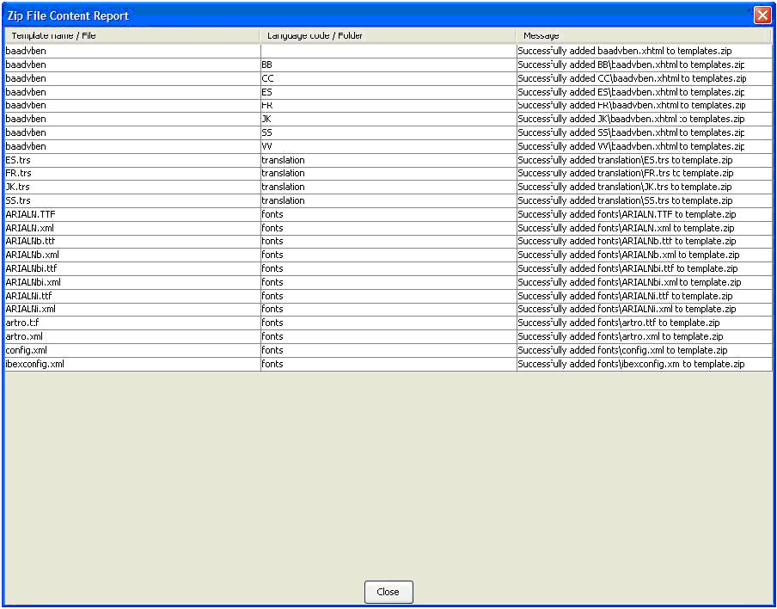

The utility includes in the zip file only those language-variant .xhtml templates found in folders where the folder's name corresponds to a language code defined in the system. The report includes a warning message if a language code sub-folder exists whose two-character name does not have a corresponding entry in the language-codes.xml file.

The Message column lists any warning or error messages. A templates.log log file in the deployment directory, which can be opened using a text editor such as Notepad, provides further information on any problems the utility encountered when creating the zip file.

The size of the templates.zip file is important. By default, the maximum size of the file is set to be 20Mb. If it exceeds this size, the upload process will fail. Your bank can change this default in the web.xml configuration file. The following code shows where this value is set.

<filter>

<filter-name>MyFacesExtensionsFilter</filter-name>

<filter-class> org.apache.myfaces.webapp.filter.ExtensionsFilter

</filter-class>

<init-param>

<param-name>maxFileSize</param-name>

<param-value>20m</param-value>

</init-param>

</filter>

## Uploading the Template Files into the System

The templates.zip file is uploaded into the system from within the system tailoring application.

Document templates are stored by default in the internal document management system within the zone. If templates are to be stored in an external document management system implemented by the bank, the upload function will store the templates in the DMS as defined in the zone system option ‘ExternalTemplatesDMSID’.

It is not recommended to store templates in multiple document management systems. The set of templates for use within a zone should be located within a single document management system.

Log on to the system and select the relevant zone. Open the system tailoring application and select the Output|Documents menu option.

In the window that appears click on the Upload Templates link.



In the window that is displayed browse to the templates.zip file and press OK.

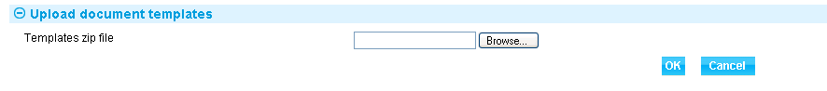

The system uploads the .zip file, extracting the template files and adding them to the DMS.

If your bank is using a DMS other than the one delivered with the system, ensure that the template files are incorporated into that system after being uploaded to the system.

See Chapter 6 (see page 47) for more information on the template-related features in this window.

## Linking Templates to Document Types

Once the template files have been loaded into the system, they can be linked to the products and events that will use them. The system tailoring application's Output|Documents menu option provides the starting point.

First select the product and event and press the Add button. A second window is displayed, with a Document Templates pane. Pressing the Add button in this pane opens a third window in which you select a transmission method. If you select Internal, Mail, Fax or Email, you can select a template from your set. In the illustration, the selected template is shown in the File Name field.

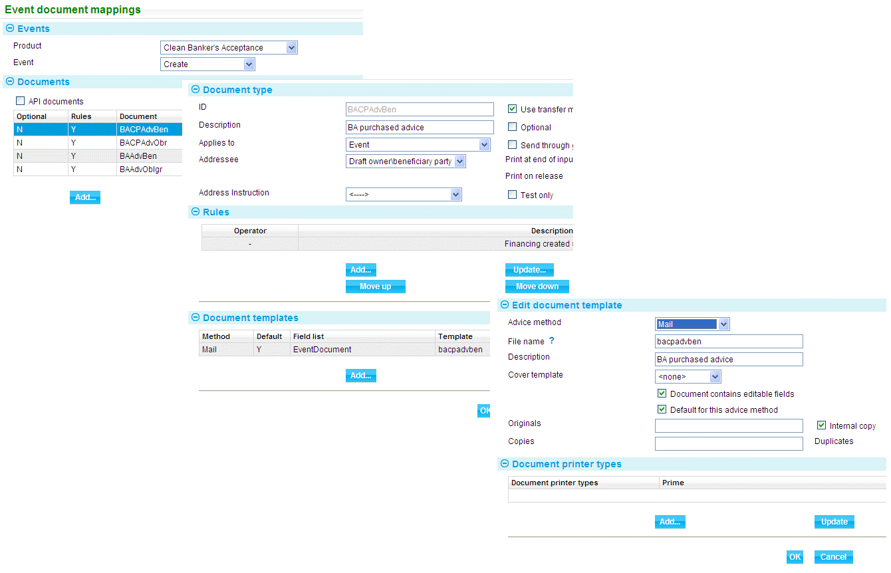

The browser on this field can be used to restrict the list of templates shown to those supported for the selected product/event combination.

For full instructions on using this functionality see the System Tailoring User Guide – Trade Innovation.

# Producing the Actual Customer Documents

This chapter explains how to generate customer documents during transaction processing in order to view their final formatting.

For full instructions on working with customer documents during transaction processing see the Common Facilities User Guide – Trade Innovation.

## Overview

During transaction processing, the system uses the document types linked to an event to determine which customer documents are to be produced.

The actual customer documents are generated once the event is released. A customer document can also be generated whilst the event is being processed.

When a document is generated, the system identifies the .xhtml template to use, and also the language variant to be used, where one exists. The .xhtml template is retrieved from the DMS and the system populates the embedded fields in the template with the event-specific data. The merged data (template file and event-specific data) is then converted to XLS format, and finally to .pdf format. Once generated, the .pdf version of the customer document is saved in the DMS.

1. When a traceable document is to be produced, the system generates the main document in PDF/A file format as this file is sent to the external document tracing system for the creation of the traceable document. The main document is generated in pdf/a so that the fonts in the document will not change and so the content will still be the same as it should when the document tracing system transforms the document into a traceable one.  
     
   Copies, duplicates and internal copy of the main document are still generated in pdf.  
     
   Refer to *System Tailoring User Guide – Trade Innovation* and *Common Facilities User Guide – Trade Innovation* for more information on traceable documents.

For customer documents in languages other than the default, the recipient’s details determine the language in which the document is to be generated. The correct language version of the template is retrieved, if it exists, together with the correct language version of any translated text strings, including clauses, provided from outside the template file. You can override this facility to select a different language version of the document, which is useful if you need to check several different language versions of a customer document.

The .pdf version of the document can be viewed whilst processing the event, and any formatting errors identified. Once an event has been completed, the .pdf file can also be retrieved from the DMS from within the Master Summary window’s Event History pane - see the Common Facilities User Guide – Trade Innovation for instructions.

1. Finastra recommends that you set up a test environment with the necessary document type/template mappings and events to allow you to generate each of the customer documents your bank will use.  
     
   Ensure that you test the language variants too, since the length of standard text will vary with the language. Check also that all the text strings provided from outside the template (that is, clauses, static data item descriptions, and text strings provided from the database) have been translated.  
     
   Before you use the facilities described in the rest of this chapter to check the layout of a customer document, ensure that you have entered all the necessary information into the event fields, so that the system can populate all the embedded fields in the template being checked and identify any required optional sections.

## Viewing Customer Documents

For full information on the facilities described in this section and instructions on how to use them see the Common Facilities User Guide – Trade Innovation.

When working in an event at an Input step, the Release Items|Documents link displays the Documents window, which lists all the documents and electronic message to be generated for the current event.

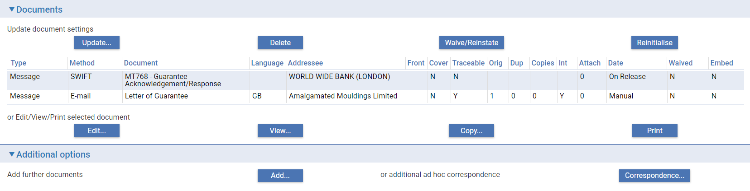

The Method column allows you to identify those customer documents that use templates - the column will contain one of the following values:

* Mail
* Fax
* Email
* Internal

To view the customer document that will be produced highlight the item and press the View button.

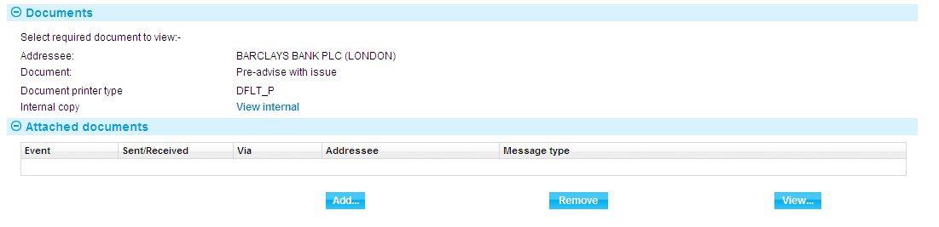

The window that appears shows the unique ID of the document printer type that is to be used to generate documents. If the template has more than one document printer type set up a drop-down list allows you to select the one to use.

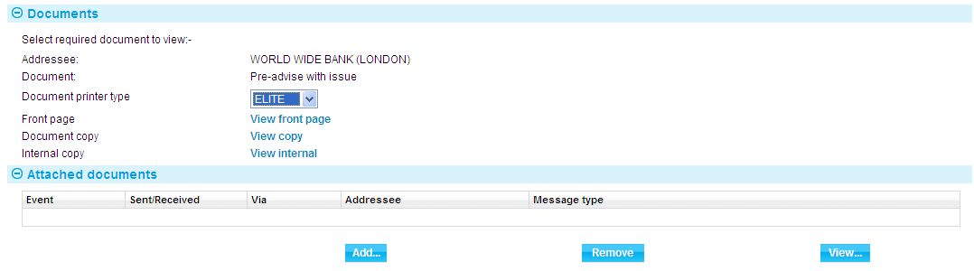

The window provides links to each of the documents that are to be produced. These can include:

* Front page
* Cover
* Traceable (Refer to *Common Facilities User Guide – Trade Innovation* for information on when a traceable document is generated for an event.)
* Original
* Duplicate
* Copies
* Internal

Click on the appropriate link.

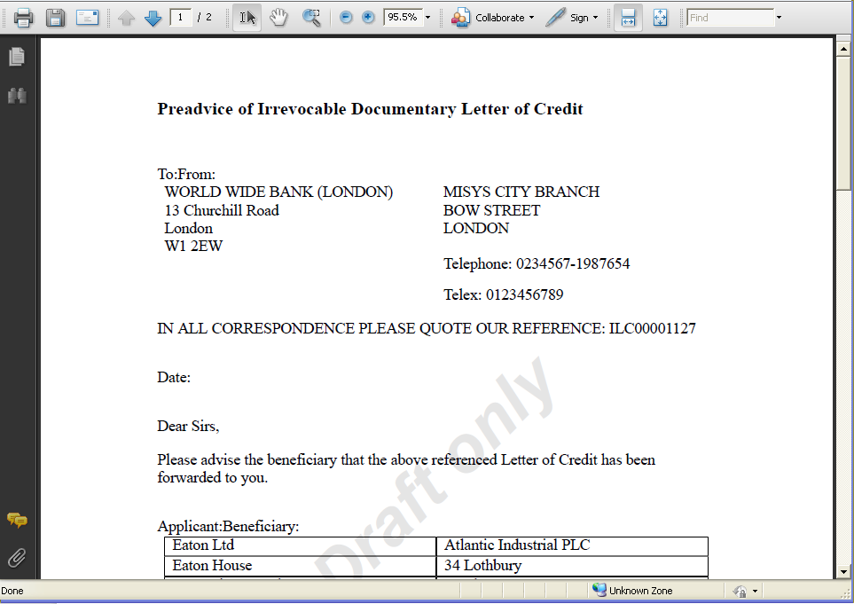

A window is opened in which you can preview the document and then print it out to check the hard copy version(s).

# Template Management

This chapter explains how to manage templates after the initial creation and take-on of your customer document template set. It provides information on fixing discrepancies, creating new templates on an ad hoc basis, and amending and deleting existing templates.

## Overview

The system tailoring application's Parameter sets|Product / event level documents menu option includes facilities that help you identify any discrepancies between the customer document template set you have provided, and what the system is set up to use.

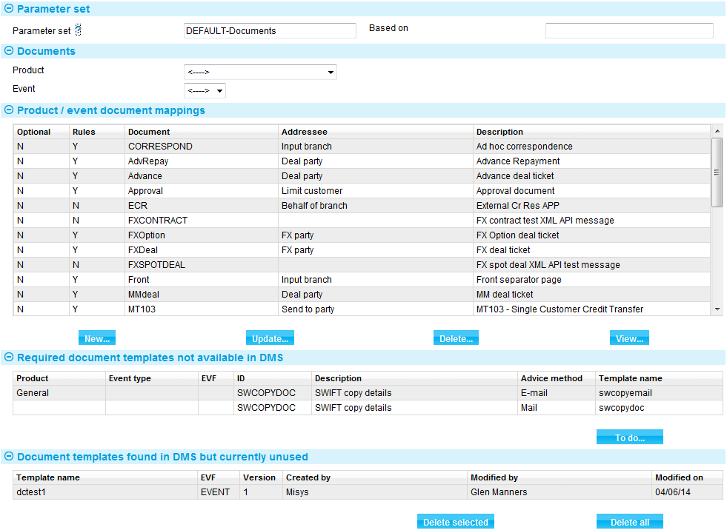

In this window:

* The Documents pane lists document types. See the System Tailoring User Guide – Trade Innovation for instructions on working with document types
* The Required Document Templates Not Available in DMS pane lists any document types that are linked to templates that have not yet been defined in the DMS (see page 48)
* The To Do button prepares a download file of missing templates, which is then used by the customer document template utility to create the required templates (see page 50)
* The Document Templates Found in DMS But Currently Unused pane lists templates that exist in the DMS, but are redundant or have not yet been linked to a document type (see page 48)
* The Download evf Files link is used to ensure that you are working with the latest set of .evf files (see page 8)
* The Upload Template link is used to upload new and amended template files into the database (see page 41)

For version 2.2.1 and onwards the following additional facilities allow you to view information on document templates and manage them:

* The All Document Mappings link provides information on all missing and redundant templates - see the next section
* The View Templates link shows information on all templates in the document management system (see page 48)

## Missing and Redundant Templates

The All Document Mappings link provides information on missing and redundant templates across all products and product/event combinations.

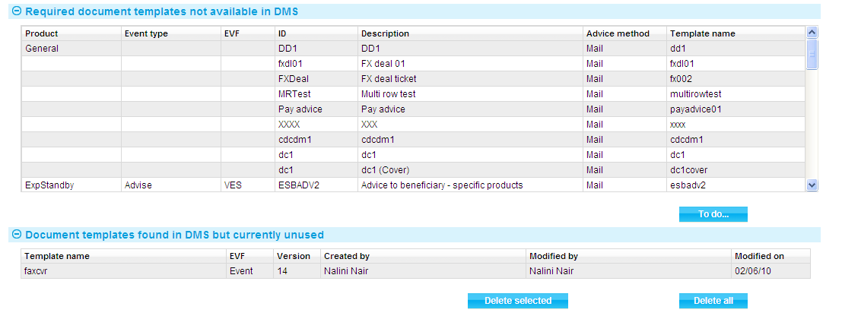

The window that is displayed when you click on this link shows information for all products.

The Required Document Templates Not Available in DMS pane lists any document types that are linked to templates that have not yet been defined in the document management system.

For each document type, the window displays information under the following headings:

|  |  |
| --- | --- |
| Heading | What it Shows |
| Product | If the document type has been set up for a specific product, the product's name is displayed. If the document type has not been set up for a particular product, this column shows 'General'. |
| Event Type | If the document type has been set up for a specific product/event combination, the event's name is displayed. |
| EVF | The evf file the template uses. |
| ID | The document type's unique ID. |
| Description | The document type's description. |
| Advice Method | The advice method used by the template. |
| Template Name | The name of the missing template. |

Pressing the To Do button allows you to prepare a download file of all the missing templates listed in this pane (see page 50).

The Document Templates Found in DMS But Currently Unused pane lists templates that exist in the document management system, but have not yet been linked to a document type. The Delete Selected and Delete All buttons allow you to delete one, several or all of the items in this list.

For each template, the window displays information under the following headings:

|  |  |
| --- | --- |
| Heading | What it Shows |
| Template Name | The name of the template. |
| EVF | The evf file the template uses. |
| Version | The version number given to the template in your document management system. |
| Created By | The person who created the template in your document management system. |
| Modified By | The person who last edited the template. |
| Modified On | The date the template was last edited. |

### Preparing a Missing Document Templates Download File

The Required Document Templates Not Available in DMS pane lists any document types that are linked to templates that have not yet been defined in the document management system. The pane includes a To Do button. Pressing this prepares a download file of missing templates, which is then used by the customer document template utility to create the required templates.

The Required Document Templates Not Available in DMS pane appears in two places:

* In the window shown when you select the system tailoring guide's Output|Documents menu option. Here it displays missing templates associated with the product/event selected
* In the window displayed when you select the All Document Mappings link. Here it displays all missing templates

Pressing the To Do button prepares a download file that includes information on only those templates displayed in the Required Document Templates Not Available in DMS pane. So you can use the system to prepare a download file covering all missing templates, or a more selective one for a particular product or product/event combination.

When you press the To Do button, the system displays a zip file creator window.

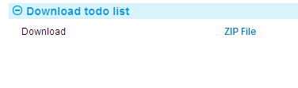

Click on the ZIP File link and follow the subsequent instructions to create the zip file using whichever third party product your bank uses.

Once you have created the zip file, give it the name:

todo.zip

and place it in the customer document utility's workspace so that the utility can find it to use to create the missing templates.

### Creating the Missing Templates

Open the todo.zip file in the customer document template utility by selecting the Transfer|Import 'to do' Files menu option.

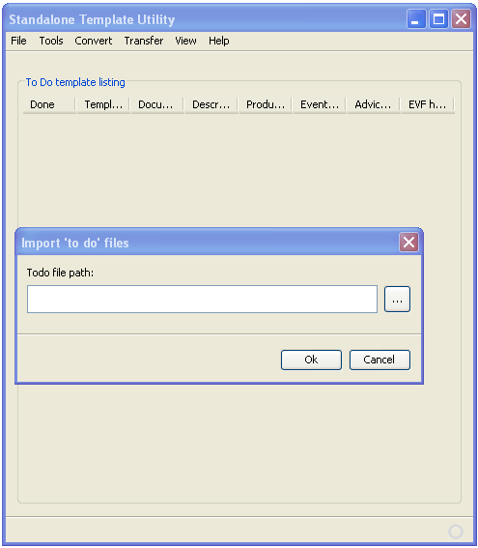

In the window that opens, navigate to the todo.zip file and then press the OK button.

Select the View|To Do menu option. The utility lists the templates in that file.

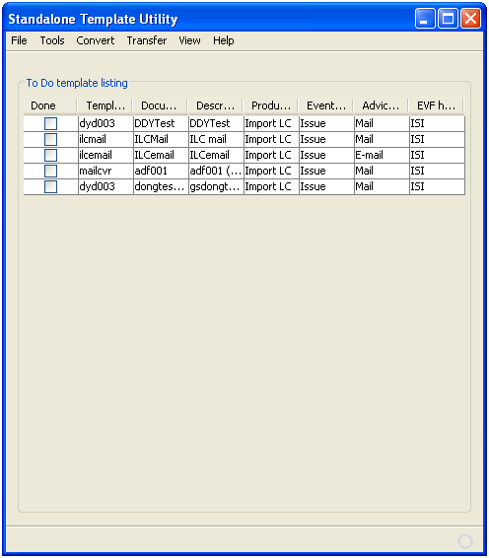

For each template it shows:

* The name of the missing template
* The ID of the document type that uses it
* The document type's description
* The product (and, if relevant, the event) for which the document type is set up
* The advice method used by the document type
* The .evf file the template uses

To create the underlying .dot file for a template, highlight it in this window, then select the Tools|New Template menu option.

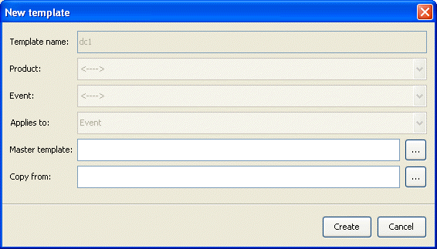

In the window that appears, the values in the first four fields are populated from the todo.zip file and you cannot change them. Otherwise, the creation of the new template now proceeds as for an individual .dot template (see page 15).

Once you have created a .dot file for a template, when you close Word and return to the customer document template utility, the Done checkbox on the line for that template is automatically checked.

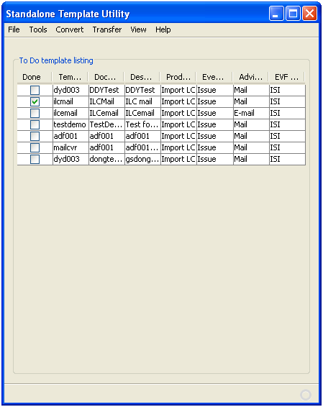

1. This window always lists the contents of the last todo.zip imported by the customer document template utility. If you import a todo.zip file that has no entries, this window will be empty.

Once you have created the necessary .dot file(s) navigate back to the utility's main screen and then:

* Convert them to .xhtml format (see page 37)
* Create a templates.zip file
* Then upload them into the system (see page 41)

## Viewing Information on Document Templates

The View Templates link shows information on templates in the document management system. You can show information for all templates, for a single template, or for templates attached to document types set up for a particular product or product/event.

The window that is displayed when you click on this link is initially blank.

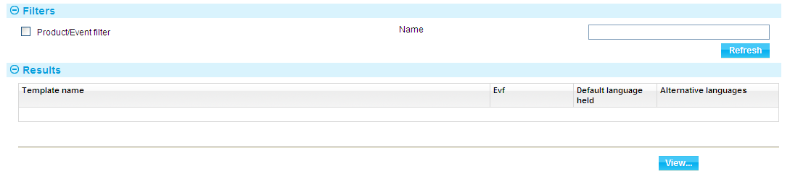

To show information on all templates, click on the Refresh button.

To show information for a single template, enter its name into the Name field and press Refresh.

To show information for a specific product or product/event combination, check the Product/Event filter field. In the fields that are displayed select the product and, if relevant, the event; then press the Refresh button. (You can use the Name filter field in conjunction with the Product and Event filter fields.)

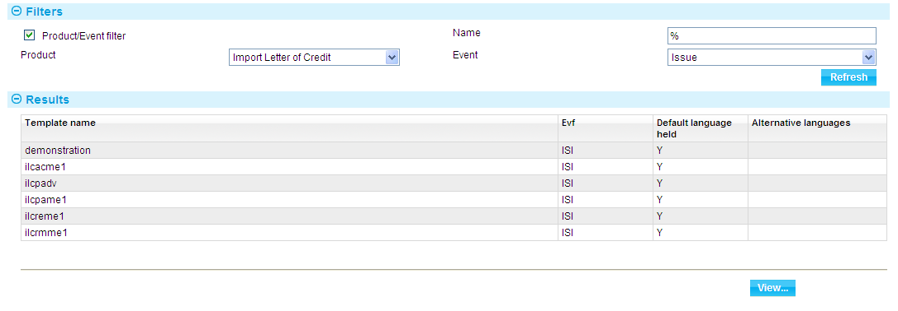

For each template, the window displays information under the following headings:

|  |  |
| --- | --- |
| Heading | What it Shows |
| Template Name | The name of the template. |
| EVF | The evf file the template uses. |
| Default Language Held | Indicates whether the document management system holds a copy of the template in your system's default language. It shows 'Y' if this is the case, otherwise 'N'. |
| Alternative Language | Shows the codes of any other languages for which versions of the template are held. |

You can view further details of an entry by highlighting it and pressing the View button.

When you select a template and click on the View button the system opens a window that shows additional information about that template.

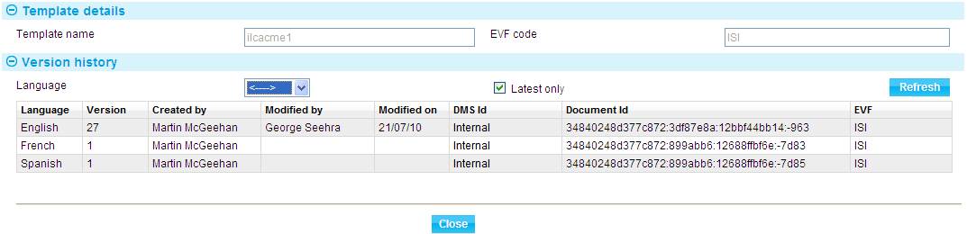

For each template, the window displays information under the following headings:

|  |  |
| --- | --- |
| Heading | What it Shows |
| Language | The language of the template. |
| Version | The version number given to the template in your document management system. |
| Created By | The person who created the template in your document management system. |
| Modified By | The person who last edited the template. |
| Modified On | The date the template was last edited. |
| DMS ID | The ID of the document management system used to store templates. Internal – if internal DMS is used. |
| Document ID | The ID of the template in the document management system. |
| EVF | The evf file the template uses. |

## Amending a Template

The process of amending an existing customer document template has the following stages:

1. Place the latest version of the .dot file in the workspace\docs folder.

Clear the workspace's xhtml folder to remove any templates previously converted and loaded into the system. This is done using the customer document template utility's Convert|Clear menu option.

Download the .evf file from the system and place it in the workspace's deployment folder.

Import the .evf files using the customer document template utility's Transfer|Import EVF Files menu option.

Make the required changes to the .dot template. Use the customer document template utility's Main|View menu option to list the .dot templates in the docs folder. Highlight the one you want to edit, then use the Tools|Edit menu option to open it.

Convert the .dot file.

Prepare the file for uploading into the system.

Upload the template into the system.

The system records the new template in the database. It retains the old version of the template, and you are able to see the successive versions of the template from within the system.

The system begins using a new template straightaway for all new customer documents generated using document types to which that template is mapped. Customer documents already created against events in progress will continue to use the old template unless the input clerk re-initialises the document (see the Common Facilities User Guide – Trade Innovation).

You can change the master .dot file and a template can be used in the following way:

In the customer document template utility use the View|Main menu option to list your templates. Highlight the template(s) to which you want to attach the master .dot file, then select the Tools|Set MSWord Property menu option.

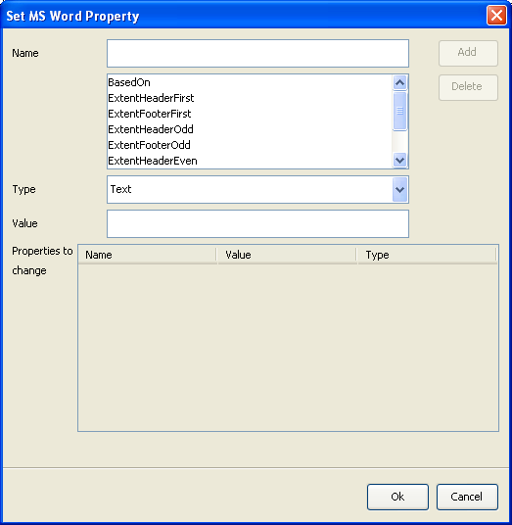

In the window that appears, select 'BasedOn' from the list by clicking on it. Set the Type field to 'Text', and enter the name of the master .dot file (without the .dot extension) into the Value field.

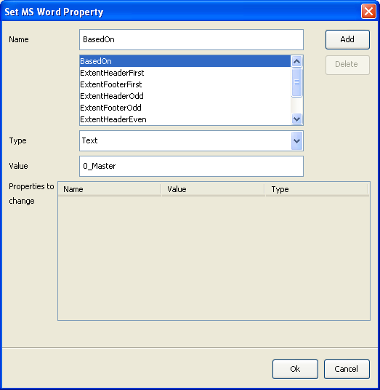

Then press **Add**. An entry is created in the Properties to Change section.

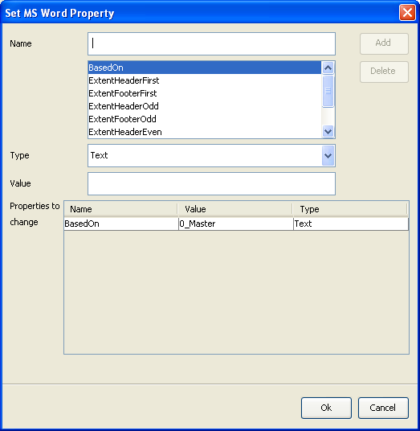

Press **OK**.

In the main customer document template utility screen, the selected entry or entries now show that they are linked to a master .dot file.

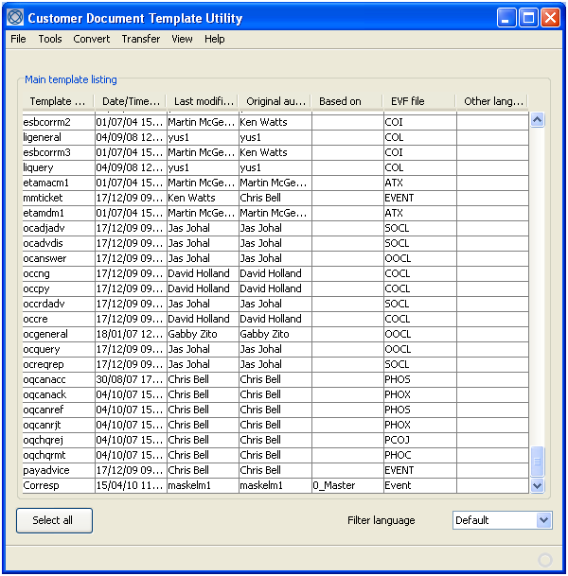

To remove the link between a template and a master file, highlight the template or templates, then select the Tools|Set MSWord Property menu option. In the window that appears select 'BasedOn', then use the Type field to select '**remove**.

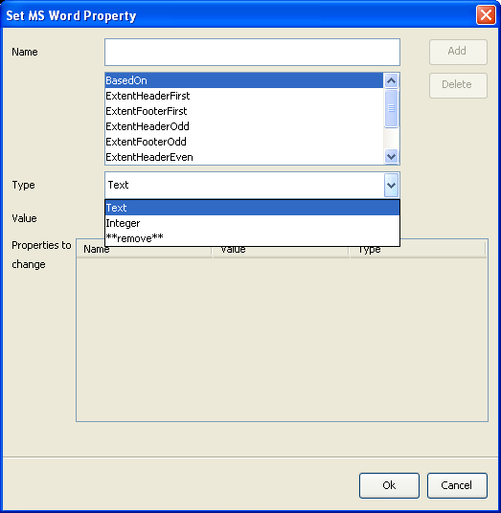

Press **Add**, then **OK**.

## Deleting a Template

The customer document template utility provides functionality to allow you to delete templates when they are no longer needed. When you delete a template the .dot file and its associated .xhtml file are both removed.

1. The deleted files are not sent to the Recycle Bin; they are deleted immediately and permanently.

When you delete a template you can delete just one language version of that template, or you can delete all language versions at the same time.

To delete just one language version of a template, in the main template listing, use the Filter Language field to select the relevant language and highlight each of the templates you wish to delete.

Then select the Tools|Delete Template|Current Language menu option.

The utility prompts you to confirm the deletion, and, once you do so, removes the selected template or templates from the system.

1. You cannot delete a template in the default language whilst other language versions of it exist; you must delete all the other language versions of it first.

To delete all language versions of a template at once, in the main template listing highlight each of the templates you wish to delete. Then select the Tools|Delete Template|All Languages menu option.

Again, the utility prompts you to confirm the deletion, and, once you do so, removes the selected template or templates from the system.

The utility deletes templates in the order in which they are displayed in the main template listing. If it encounters an error during the deletion process, it abandons the process at the template causing the error. All templates before that one are deleted, but the template in error and all the templates following it remain undeleted.

# Troubleshooting

This chapter covers customer document utility settings relevant to troubleshooting and identifies and provides solutions to some of the common problems you may encounter when using the utility.

## Customer Document Template Utility Settings

When the customer document utility loads .dot templates, the process involves opening Word for each template file as a background task. You can configure the utility so that it opens Word for more than one template file at a time, thereby potentially speeding up the process.

Select the File|Setup menu option. In the window that appears enter a number between 1 and 999 - the higher the number the quicker the utility will run when listing templates (although this also depends on the specification of the PC you are running).

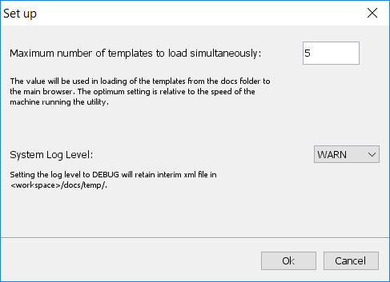

In this window, the System Log Level allows you to set the level for logging the utility's processes. By default the logging level is set to INFO. Do not change this value unless instructed to do so by your local Finastra support branch.

The Help|About menu option displays a window that provides information about the version of the utility you are running.

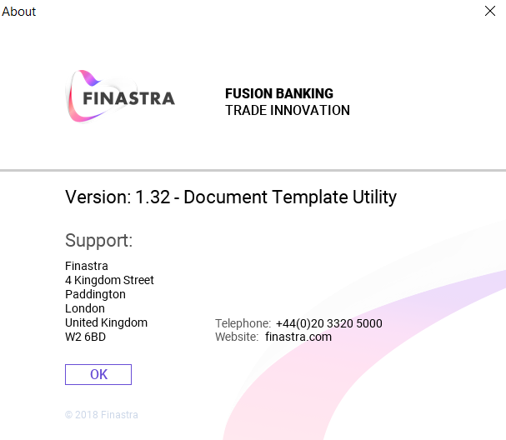

## Troubleshooting the Customer Document Template Utility

| Problem | Solution |
| --- | --- |
| All Word templates flash on screen. | You have attempted to open a Word document while the conversion from that .dot file to xhtml is in progress. |
| The utility seems to suspend (hang) while using the Tools|Set MSWord Property menu option. | The utility is trying to set a property on a Word document that is open. Close the relevant Word document. |
| It takes a long time (more than a minute) for the main browser GUI to appear as you start the utility. | This is normal if you define a new workspace with several word templates already in place (in the docs folder) or if you have just added several templates to the docs folder. The utility is creating an index of the templates. The status bar at the bottom left of the window shows the templates being processed. |
| The utility crashes, and subsequently the files and folders it uses are locked or can be opened only in read-only mode. | Close all word documents. Open Windows Task Manager and terminate (using the End Process button) all instances of winword.exe. Restart your PC. |
| You update a language variant folder with templates by manually copying templates into it or through synchronising it with your document management system. The utility does not recognise the newly added templates. | Use the View|Refresh menu option. |
| You manually create a new language variant folder or create one through synchronising with your document management system. The utility does not recognise the new folder. | Use the View|Refresh menu option.  Ensure that the folder has a name that corresponds to a language code defined in the system. |
| You experience an error message when transforming fonts using the Convert|Fonts menu option. | Check that:   * You have entered a file name, not a directory name, in each of the four fields used to define fonts * You have provided a valid font name - check the spelling of the name and the spaces |

## Troubleshooting Fonts

When setting up fonts for use in producing customer documents (see page 6) the font name entered into the customer document template utility must match the name given to the font, as displayed in Word.

You can check that the fonts your bank uses have been set up correctly using the file ibexconfig.xml and, if necessary, fix them by editing this file. It is located in the workspace/fonts folder.

This file contains all the fonts used by the customer document templates. The following code provides an example of the file's content:

<?xml version="1.0" encoding="UTF-8"?>

<ibexconfig>

<font bold="false" file="fonts/cour.ttf" italic="false" name="courier new"/>

<font bold="true" file="fonts/courbd.ttf" italic="false" name="courier new"/>

<font bold="false" file="fonts/couri.ttf" italic="true" name="courier new"/>

<font bold="true" file="fonts/courbi.ttf" italic="true" name="courier new"/>

<font bold="false" file="fonts/times.ttf" italic="false" name="times new roman"/>

<font bold="true" file="fonts/timesbd.ttf" italic="false" name="times new roman"/>

<font bold="false" file="fonts/timesi.ttf" italic="true" name="times new roman"/>

<font bold="true" file="fonts/timesbi.ttf" italic="true" name="times new roman"/>

<font bold="false" file="fonts/arial.ttf" italic="false" name="arial"/>

<font bold="true" file="fonts/arialbd.ttf" italic="false" name="arial"/>

<font bold="false" file="fonts/ariali.ttf" italic="true" name="arial"/>

<font bold="true" file="fonts/arialbi.ttf" italic="true" name="arial"/>

<font bold="false" file="fonts/verdana.ttf" italic="false" name="verdana"/>

<font bold="true" file="fonts/verdanab.ttf" italic="false" name="verdana"/>

<font bold="false" file="fonts/verdanai.ttf" italic="true" name="verdana"/>

<font bold="true" file="fonts/verdanaz.ttf" italic="true" name="verdana"/>

</ibexconfig>

# Appendix A

This appendix provides instructions on installing and uninstalling the customer document template utility.

## Prerequisites

Below are the minimum requirements for the Document Template Utility.

1. The DTU tool calls to a scripting language called PERL in this release. As PERL is a third-party product, Finastra cannot build or alter it. The current version of PERL does not support a new feature of MS Windows Security called Exploit mitigation - Force randomisation of images (Mandatory ASLR). By default, this setting is OFF when installing Windows and is meant to be set on per program. If this option is set on Globally on the DTU installation computer, then PERL will not work.

### DTU Latest Release

* Microsoft Windows 32bit or 64bit
* Windows Server 2003, 2008, 2008 R2, 2012
* Windows 2000, Vista, XP, 7, 8
* Java 1.5.* -1.6.*
* MS Word 2003, 2007, 2010, 2013, Office 365 (all 32-bit)
* Adobe Reader 6.0 or higher

## Installing the Customer Document Template Utility

This section explains how to install the customer document templates utility.

Download the file TI_Plus_Utilities.exe to the PC on which you will be working.

Double click on the TI_Plus_Utilities.exe file.

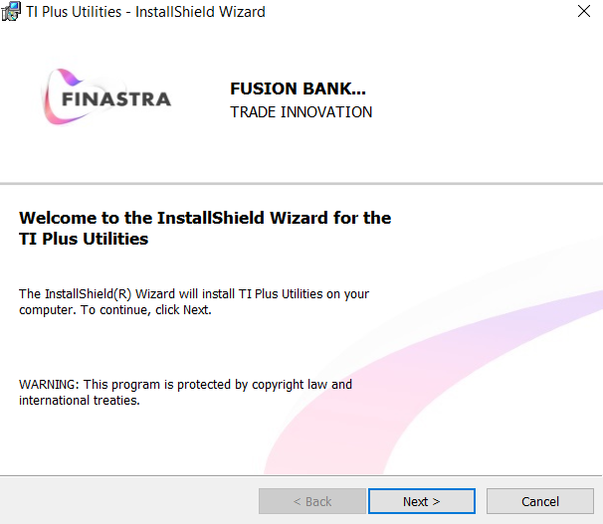

An installation wizard is opened. Click the Next button from each window to proceed through the installation procedure.

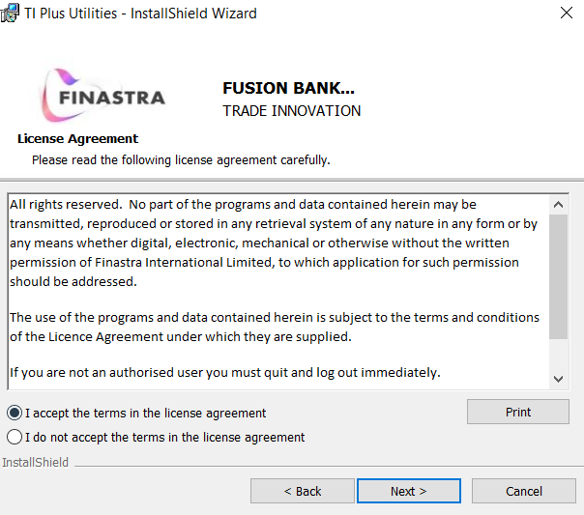

In the license agreement page use the radio button to accept the terms of the license agreement.

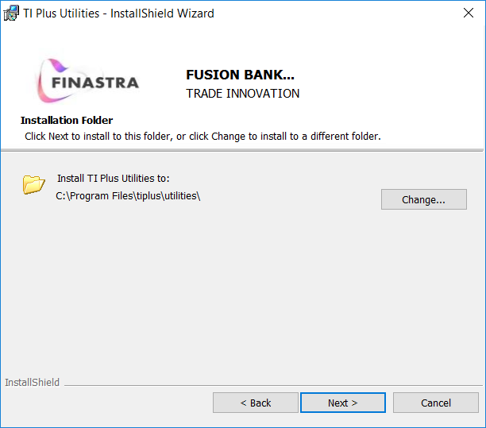

The wizard uses the default path illustrated above to install the utility. To install it to a different location use the Browse button to identify the path to the folder where you want to install it.

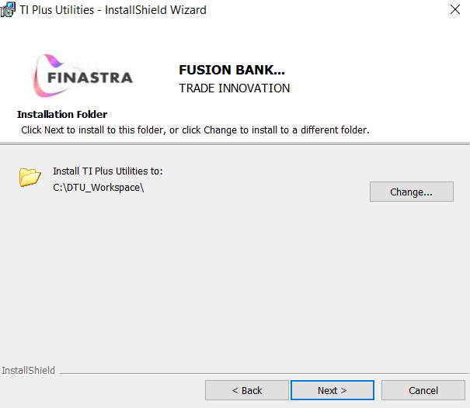

The wizard provides a path to the root folder of the workspace the utility will use initially when you open it. You can do one of three things:

* Accept the default path, in which case the wizard will create the workspace if it does not already exist
* Type in an alternative path, in which case the wizard will again create the workspace if it does not already exist
* Use the Browse button to locate the root directory of a workspace you have already set up

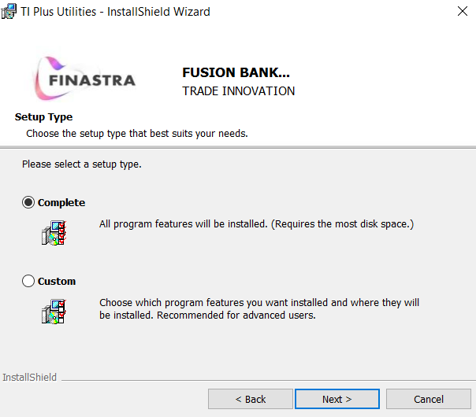

Unless instructed otherwise by Finastra, select a typical installation.

(Selecting a custom installation allows you to choose not to install certain elements of the utility.)

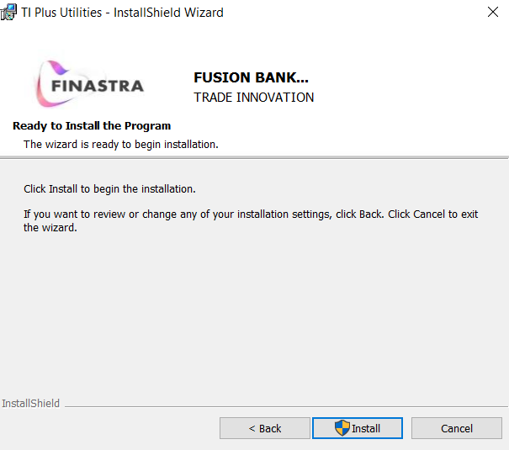

A summary page displays the installation choices you have made so far. Check that they are what you want before proceeding to the next window. When you click on the Install button from within this window the wizard proceeds to install the utility. A final window is displayed confirming when the installation has completed.

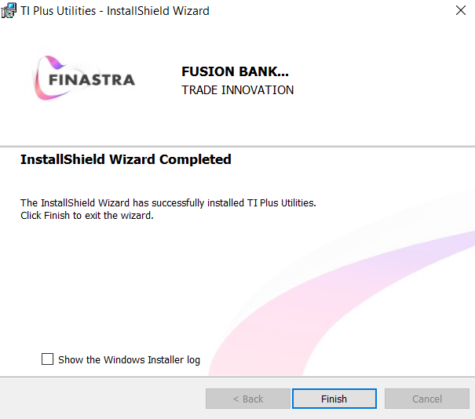

Click **Finish**.

## Uninstalling the Customer Document Template Utility

The customer document template utility can be removed from a PC using the following standard Microsoft functionality:

Start > Control Panel > Programs and Features > TI Plus Utilities > Uninstall

The software programs will be deleted from the PC using this process, but any workspaces set up on the PC will need to be deleted manually.